1. **CI/CD pipeline using git, Jenkins and maven:**

Setup Jenkins Server:

1. Setup a Linux ec2 instance

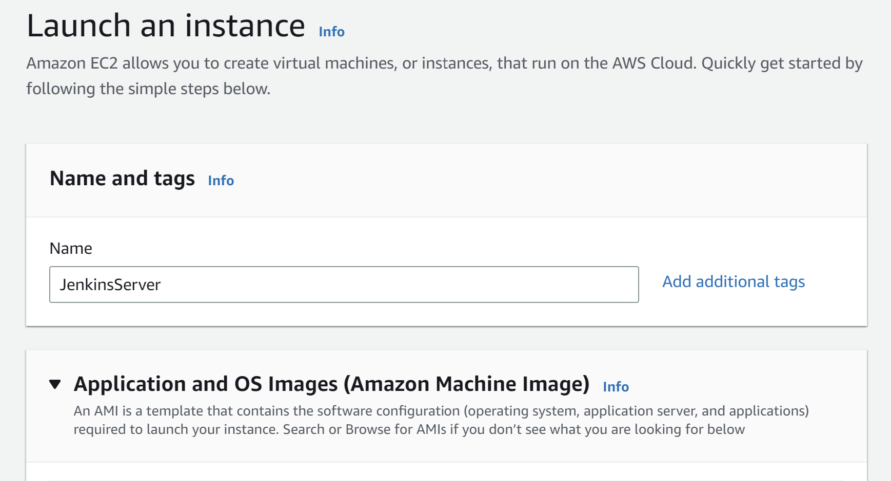

Creating key in ec2 instance:

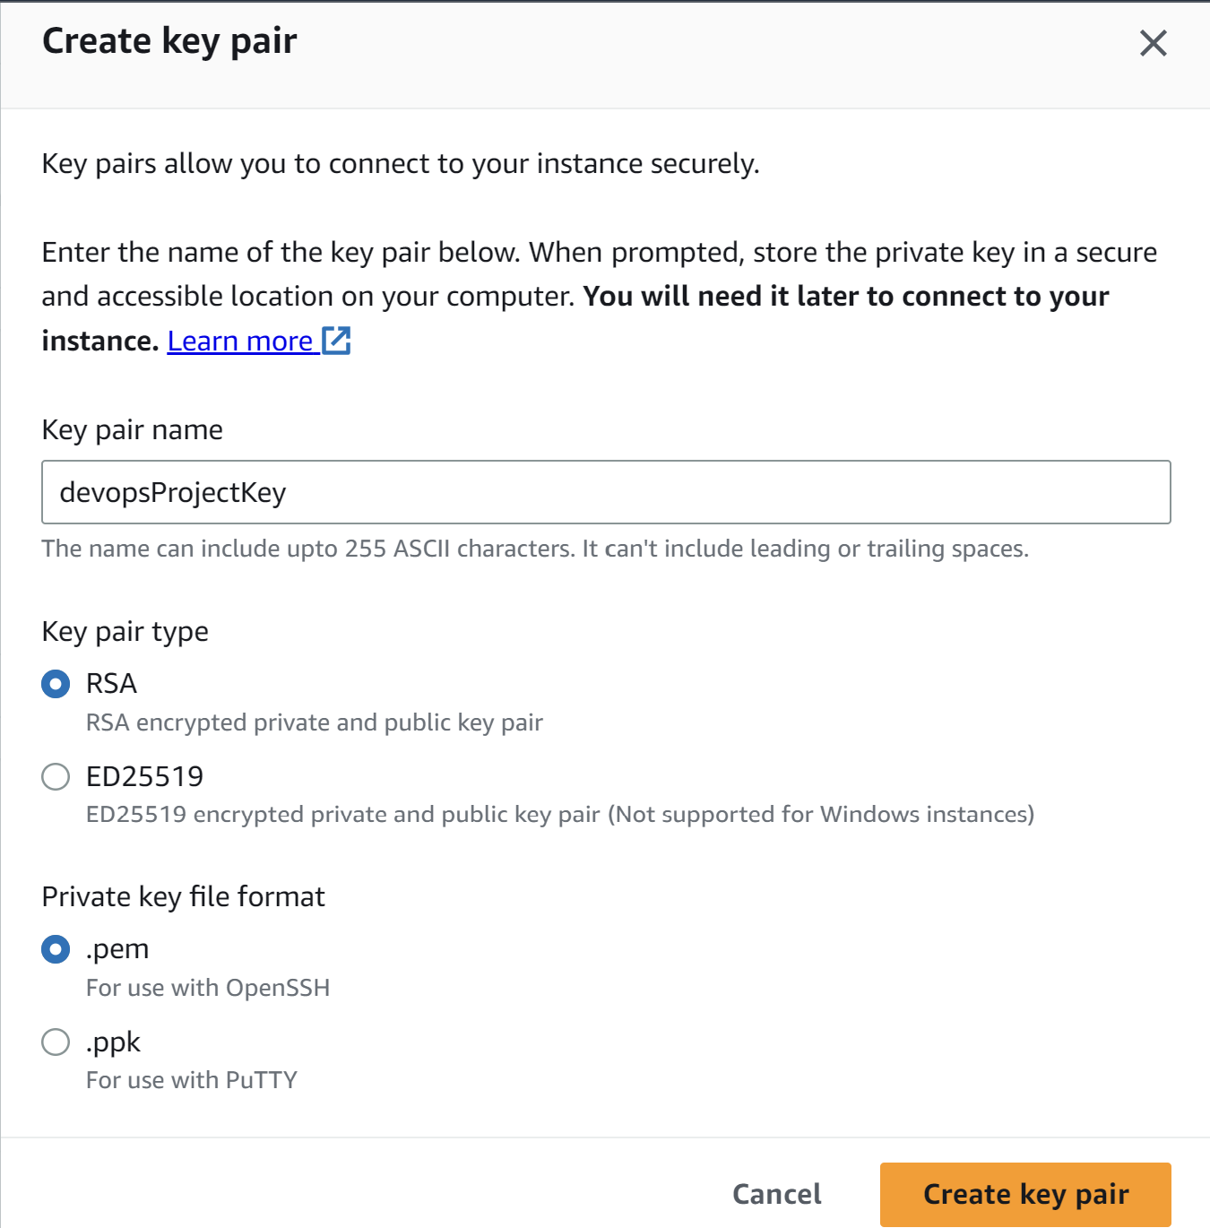

Edit inbound rules for port 8080:

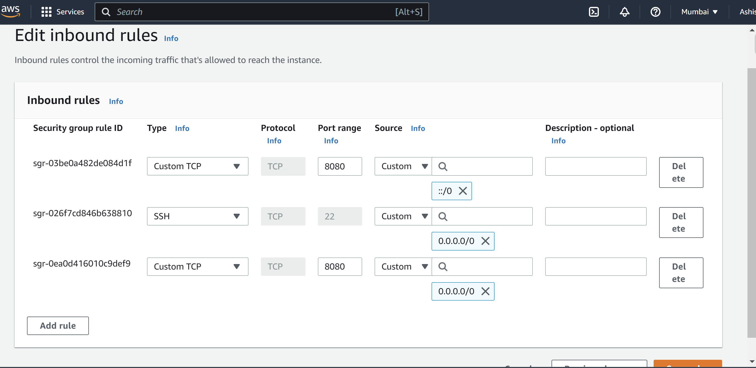

We can use mobaxterm software to connect to ec2 instance, can use both linux and GUI for the server:

**Go to 🡪** session>ssh> enter IP address and username(default-ec2-user) and add pem file(downloaded during creation of ec2 instance).

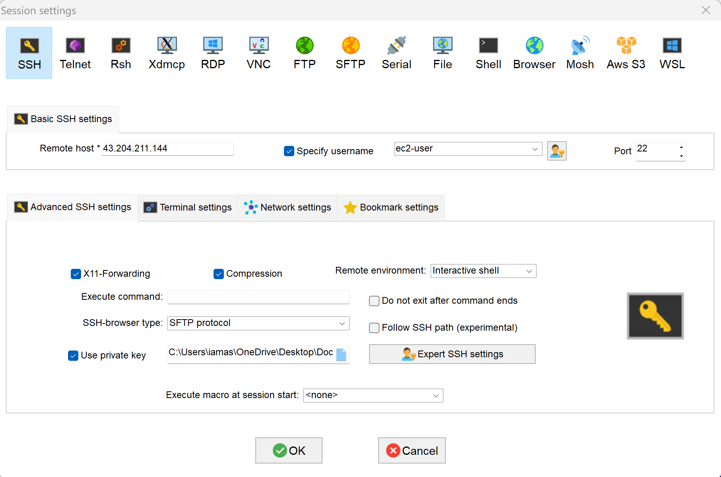

To become a super user or root user **🡪 sudo su –**

Go to official Jenkins site for the instruction for stable release for [Red Hat/Fedora/Alma/Rocky/CentOS](https://pkg.jenkins.io/redhat-stable/)

1. **Install java and** Jenkins

sudo wget -O /etc/yum.repos.d/jenkins.repo https://pkg.jenkins.io/redhat-

stable/jenkins.repo

sudo rpm --import https://pkg.jenkins.io/redhat-stable/jenkins.io.key

amazon-linux-extras install epel **(Will work on amazon linux2 instances only)**

amazon-linux-extras install java-openjdk11

java -version (check java version)

yum install Jenkins

service Jenkins start 🡪 to start Jenkins

service Jenkins status 🡪 to check status

open the Jenkins server on🡪 PublicIpAddress:8080

**if it asks for administrative password then open the file using cat command mentioned in the ui and use that password.**

**Default username :** admin

**Password:** cat /var/lib/jenkins/secrets/initialAdminPassword

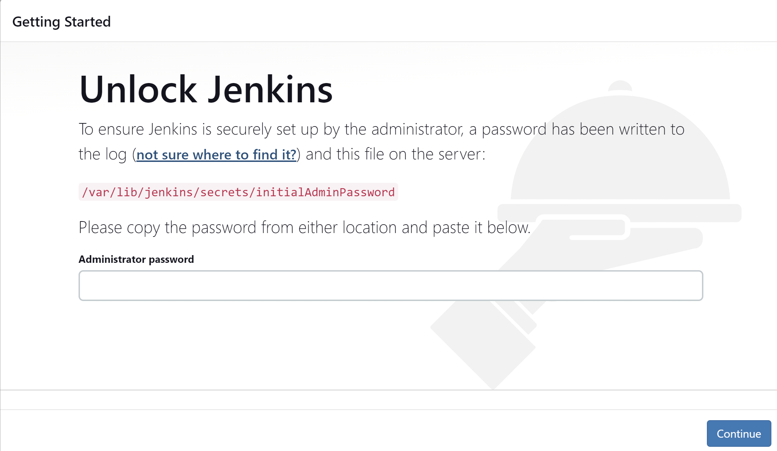

**Running our first Jenkins Job:**

**New item>freestyle project**

**On build steps choose execute shell:**

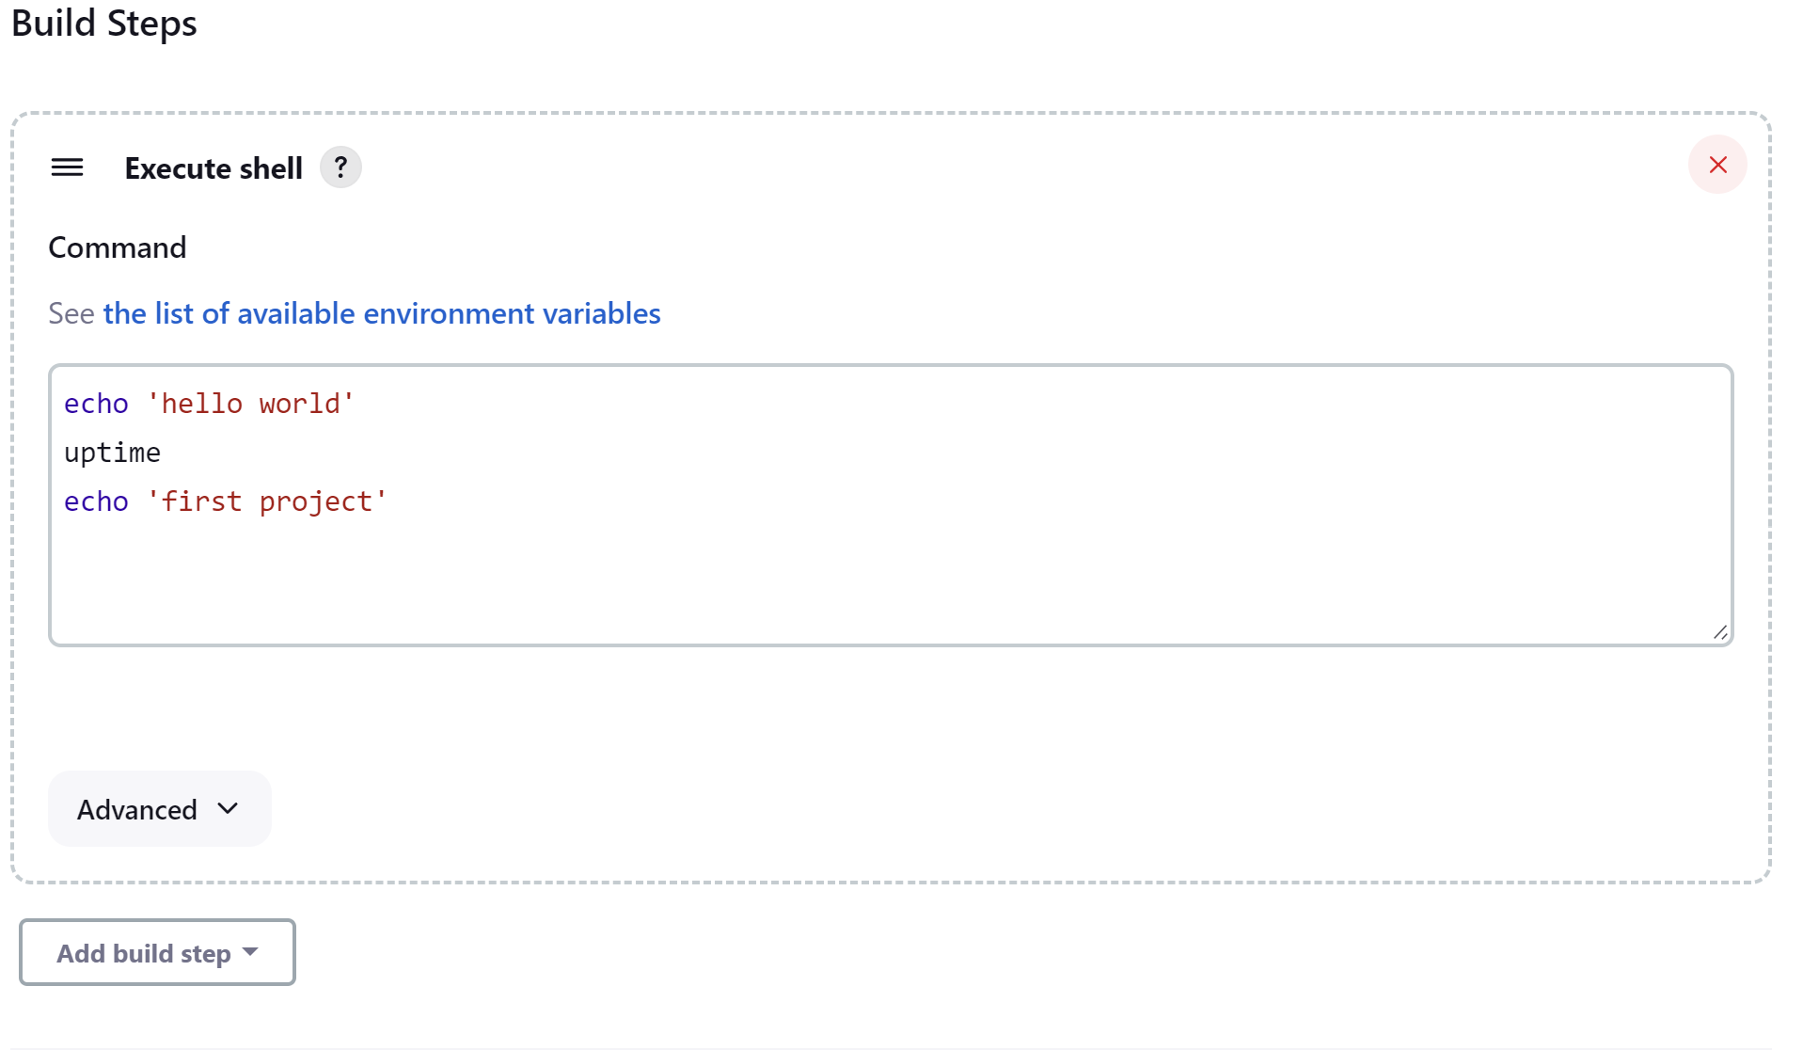

**Output when we do build now.**

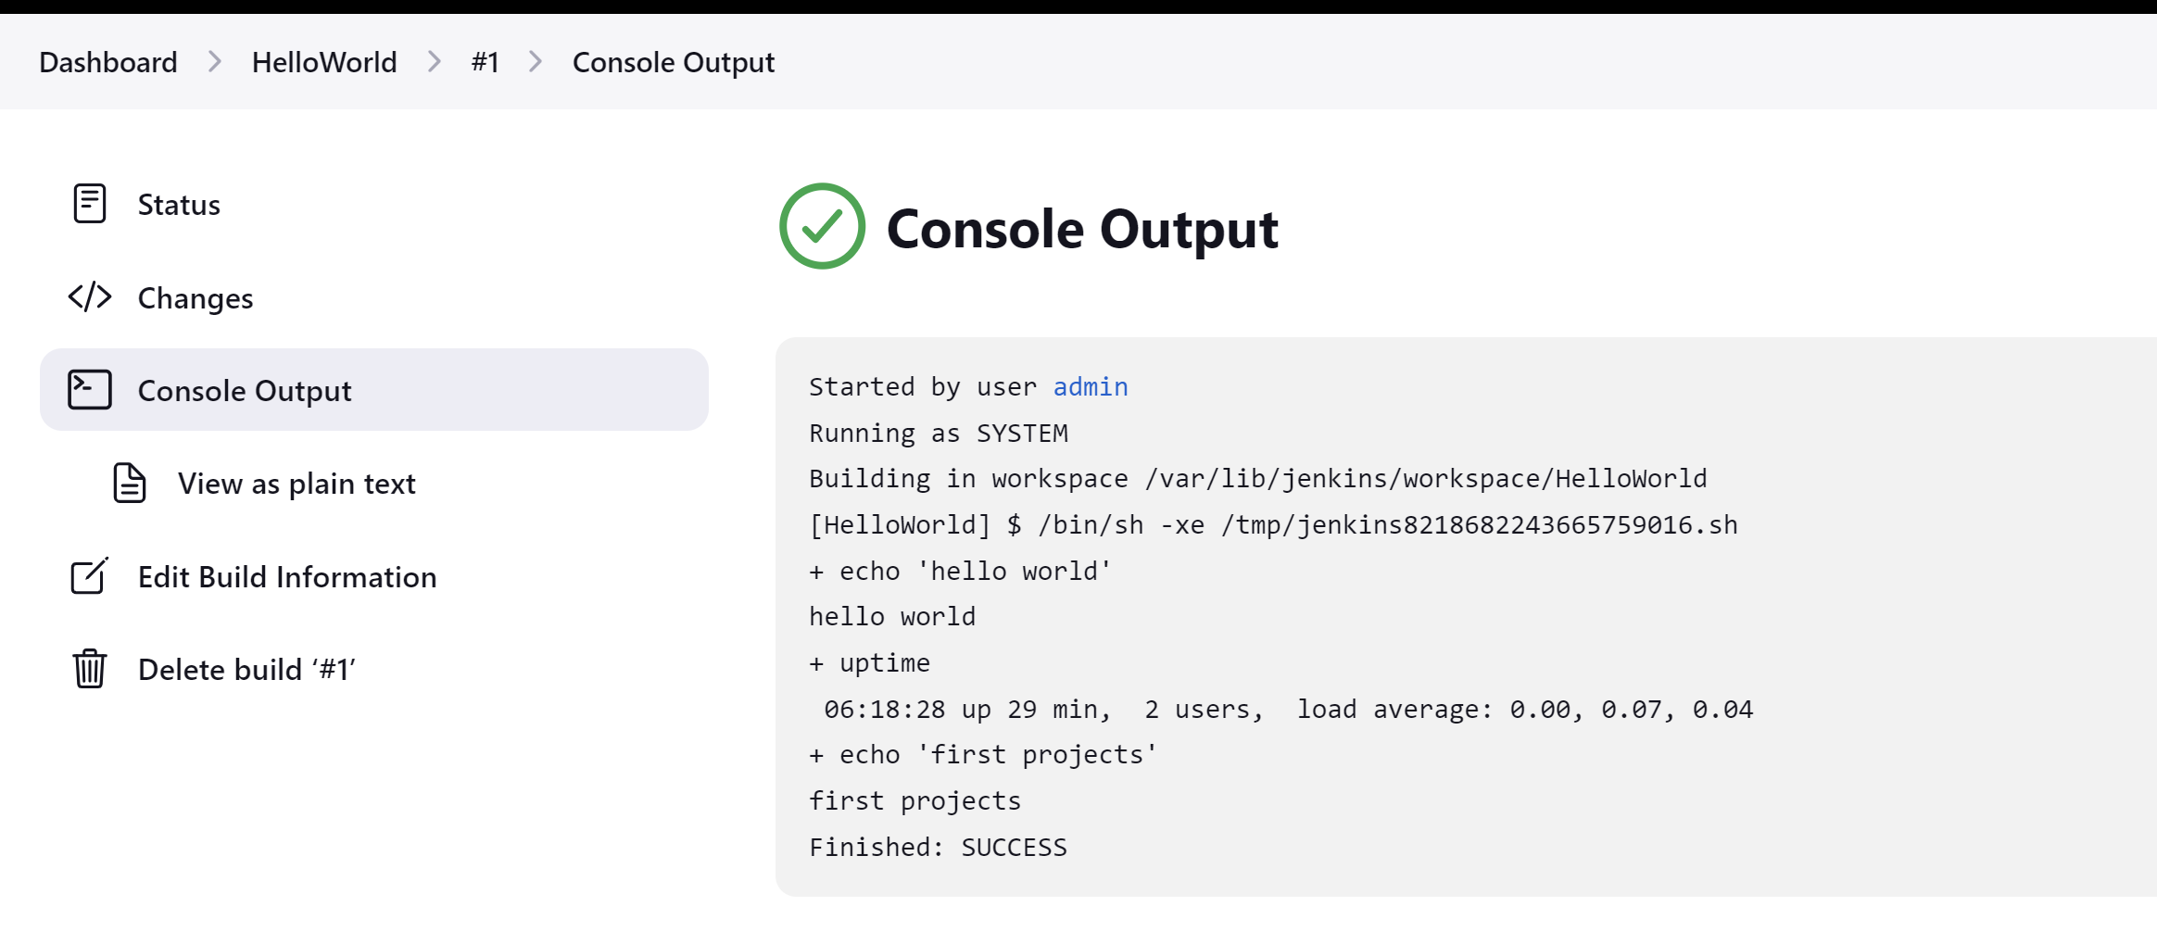

1. **CI/CD using git, Jenkins and Maven:**

**Integrating git with jenkins**

**Installing git on linux as :**

yum install git

**Adding GitHub plugin:**

**Go to 🡪** manage Jenkins>manage plugins>search for “**github**” and install it.

**Configuring git in Jenkins so that it can use commands to pick the code and other operations.**

**Go to 🡪** manage Jenkins>Global tool configurations

**On Git installation section configure git.**

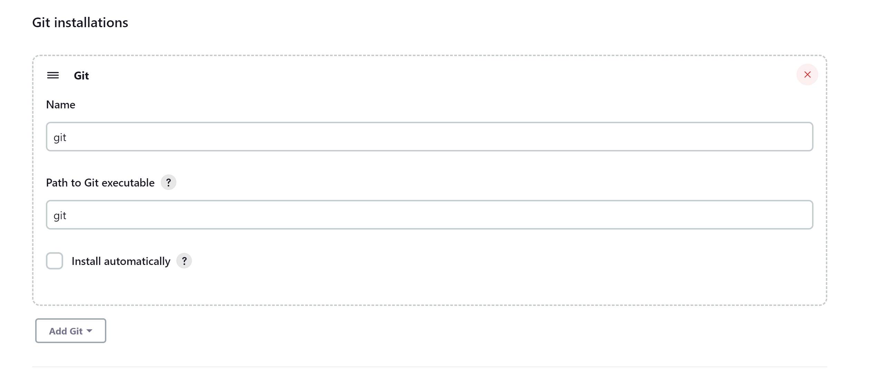

After configuring git and github we will have git present in source code management section.

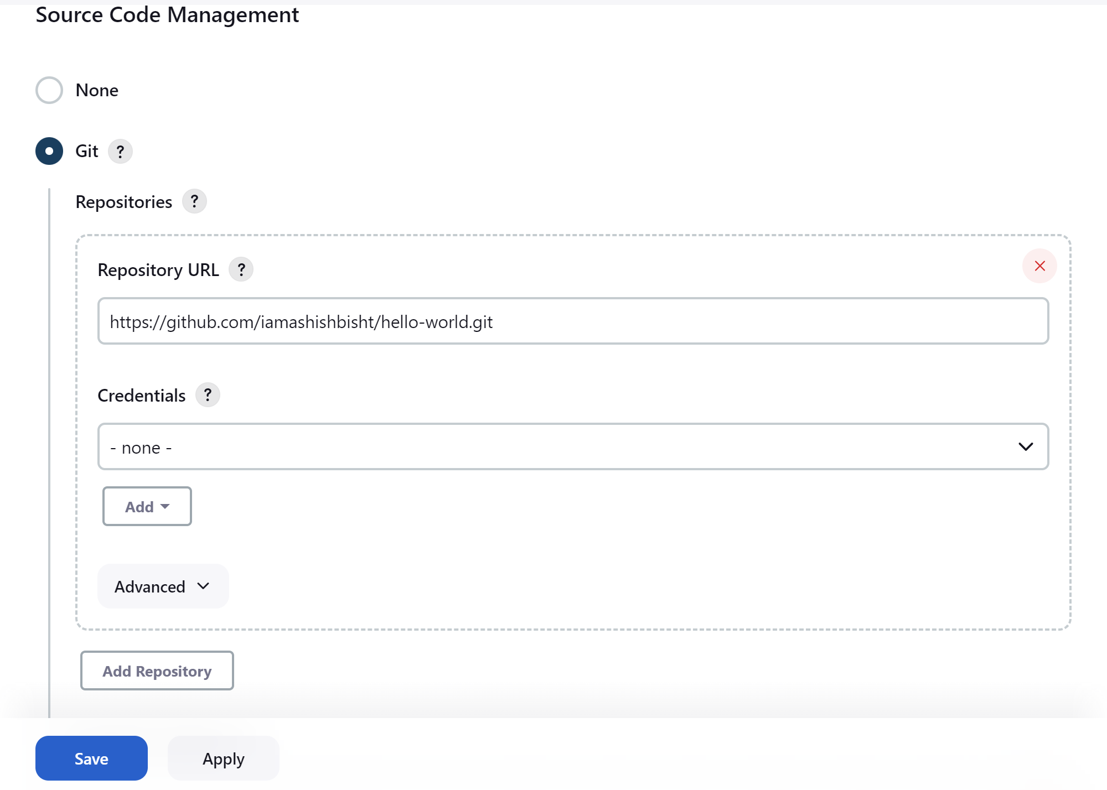

Building the project after doing git configuration:

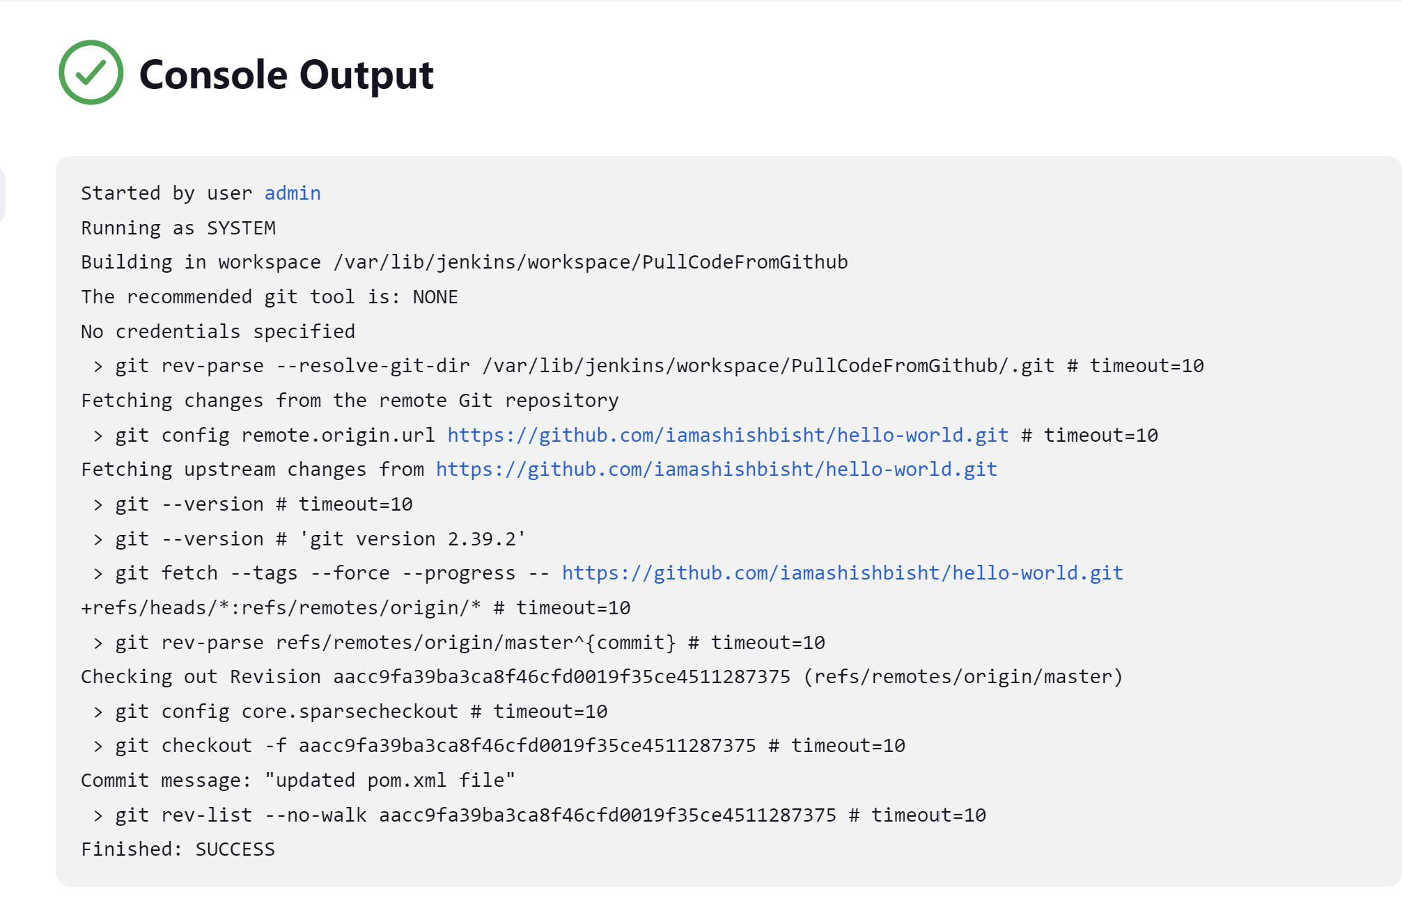

All the Jenkins jobs stores the job in the folder mentioned in console output as /var/lib/jenkins/workspace/PullCodeFromGithub

**Integrating Maven with Jenkins**

Can use a different server for maven build. But will use same server.

Go to /opt folder (this folder is reserved for add on installation software) and download tar file for maven as:

**wget** [**https://dlcdn.apache.org/maven/maven-3/3.9.1/binaries/apache-maven-3.9.1-bin.tar.gz**](https://dlcdn.apache.org/maven/maven-3/3.9.1/binaries/apache-maven-3.9.1-bin.tar.gz)

**extract the downloaded package as:** tar -xvzf apache-maven-3.9.1-bin.tar.gz

moving this file in maven folder: mv apache-maven-3.9.1 maven

to get java 11 path command is : find / -name java-11*

setting environment variable in .bash_profile in /root directory as:

1. vi .bash_profile 🡪 edit the file with:

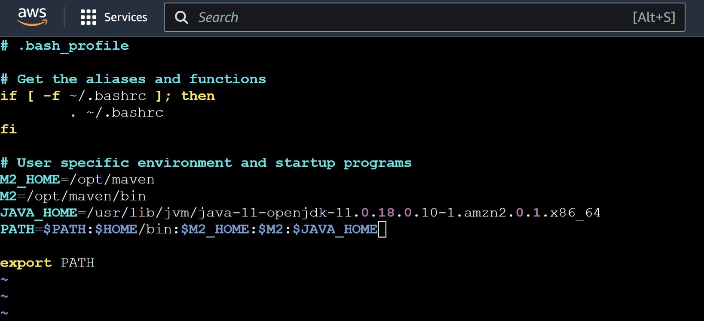

Changes will be reflected for the path if we restart the server or refresh the file to read newly changed file as : **source .bash_profile**

**Maven Integration in Jenkins.**

**Add maven integration plugin from manage Jenkins>manage plugins**

**Now configuring it in Global tool configuration as:**

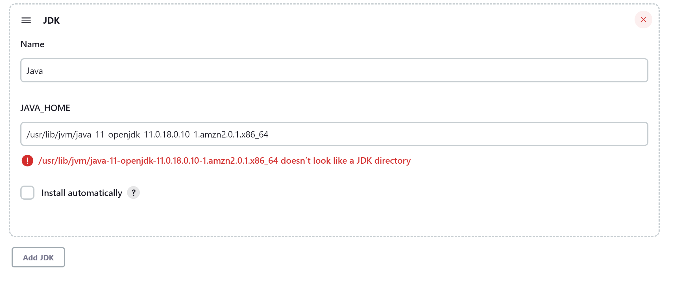

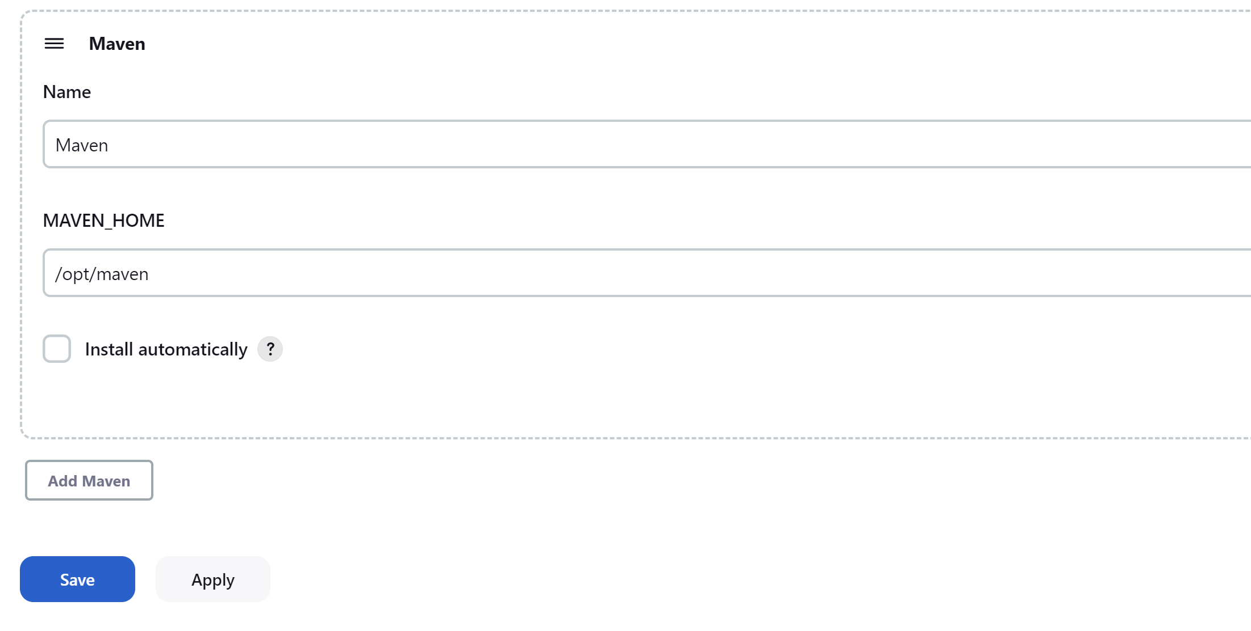

Now creating a maven project in Jenkins as:

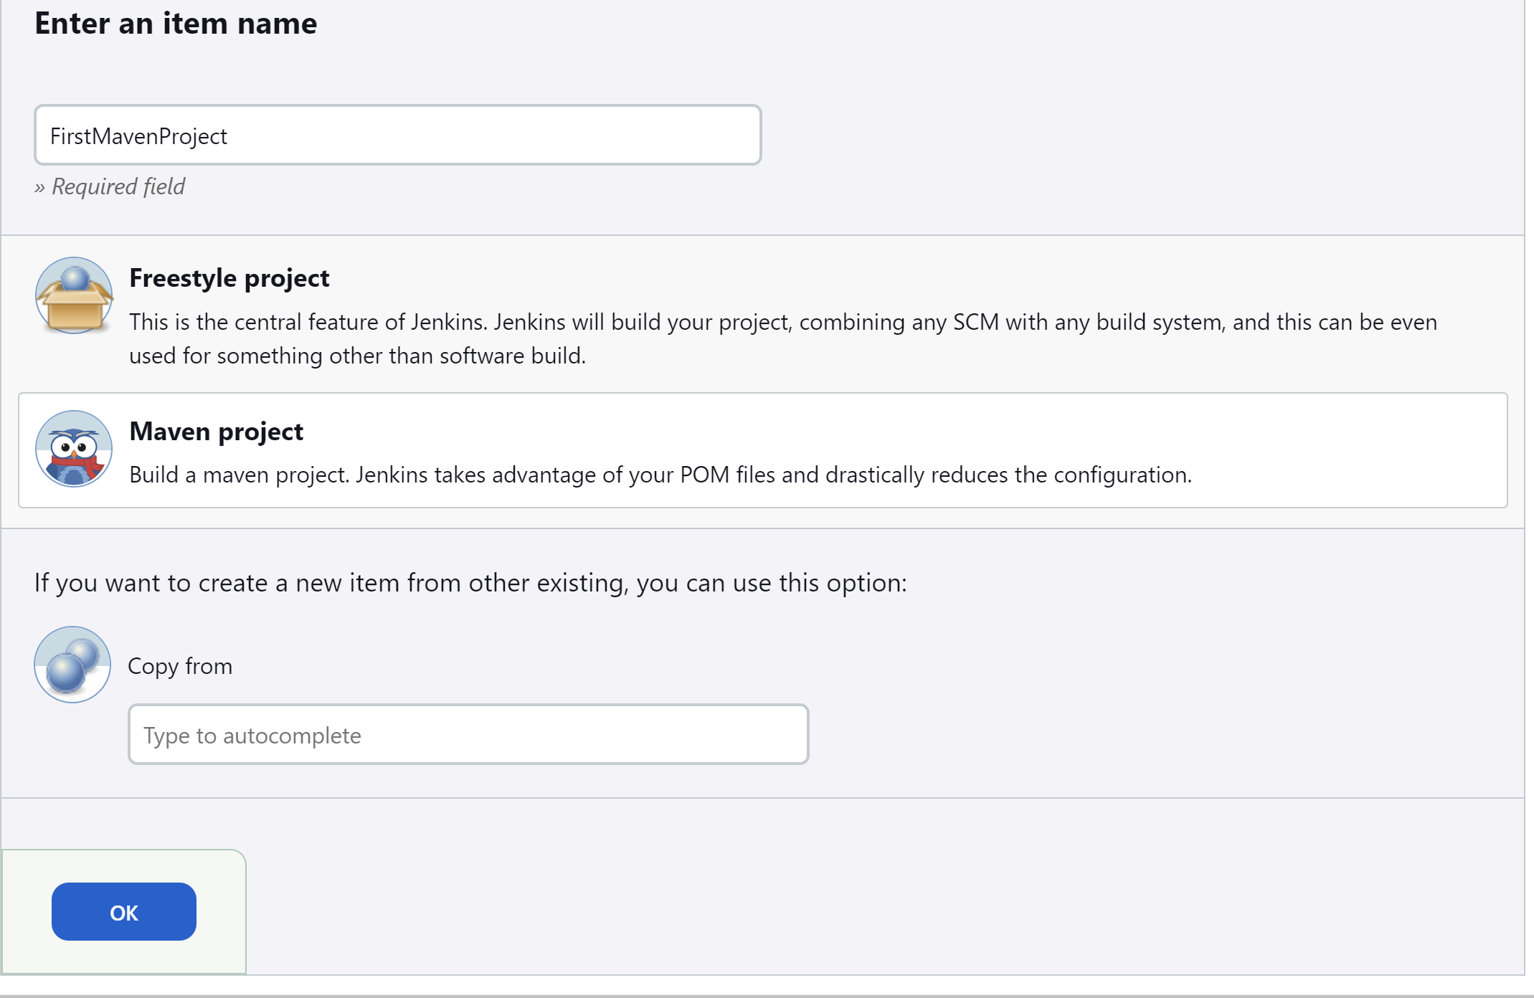

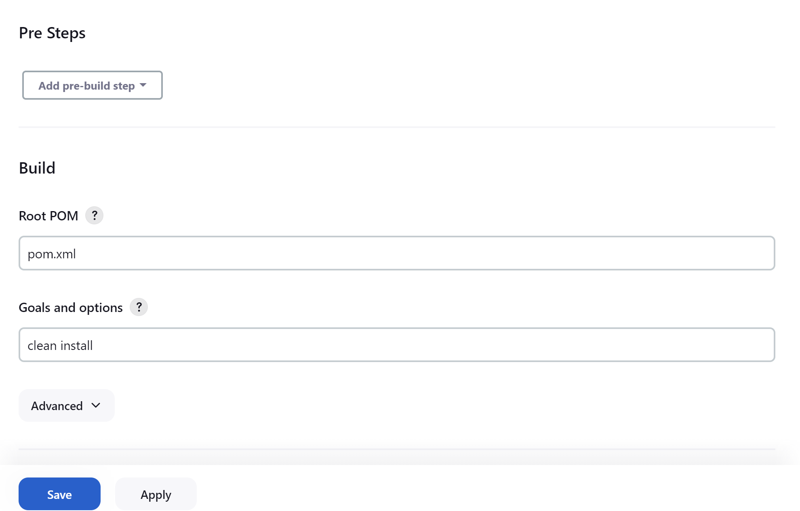

Console logs for project build

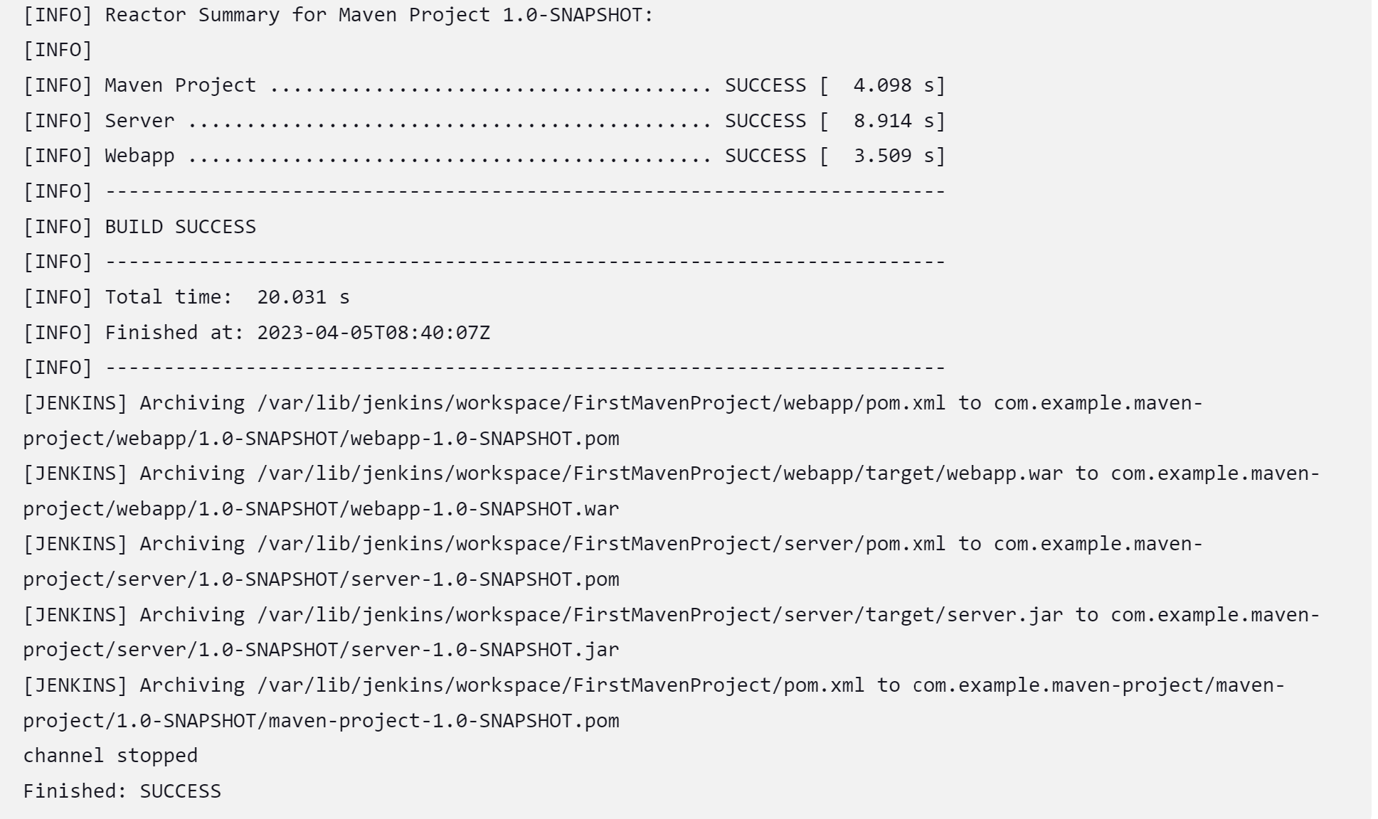

1. **Integration Tomcat Server in CI/CD pipeline:**

Launch a instance for tomcat server in AWS.

Download tomcat for linux in **/opt** folder using: wget <https://dlcdn.apache.org/tomcat/tomcat-9/v9.0.73/bin/apache-tomcat-9.0.73.tar.gz>

Unzip the file and start the tomcat using **./startup.sh**

To run Tomcat we need jdk to be installed. So on the tomcat server install java.

**amazon-linux-extras install java-openjdk11**

Hit tomcat at port 8080

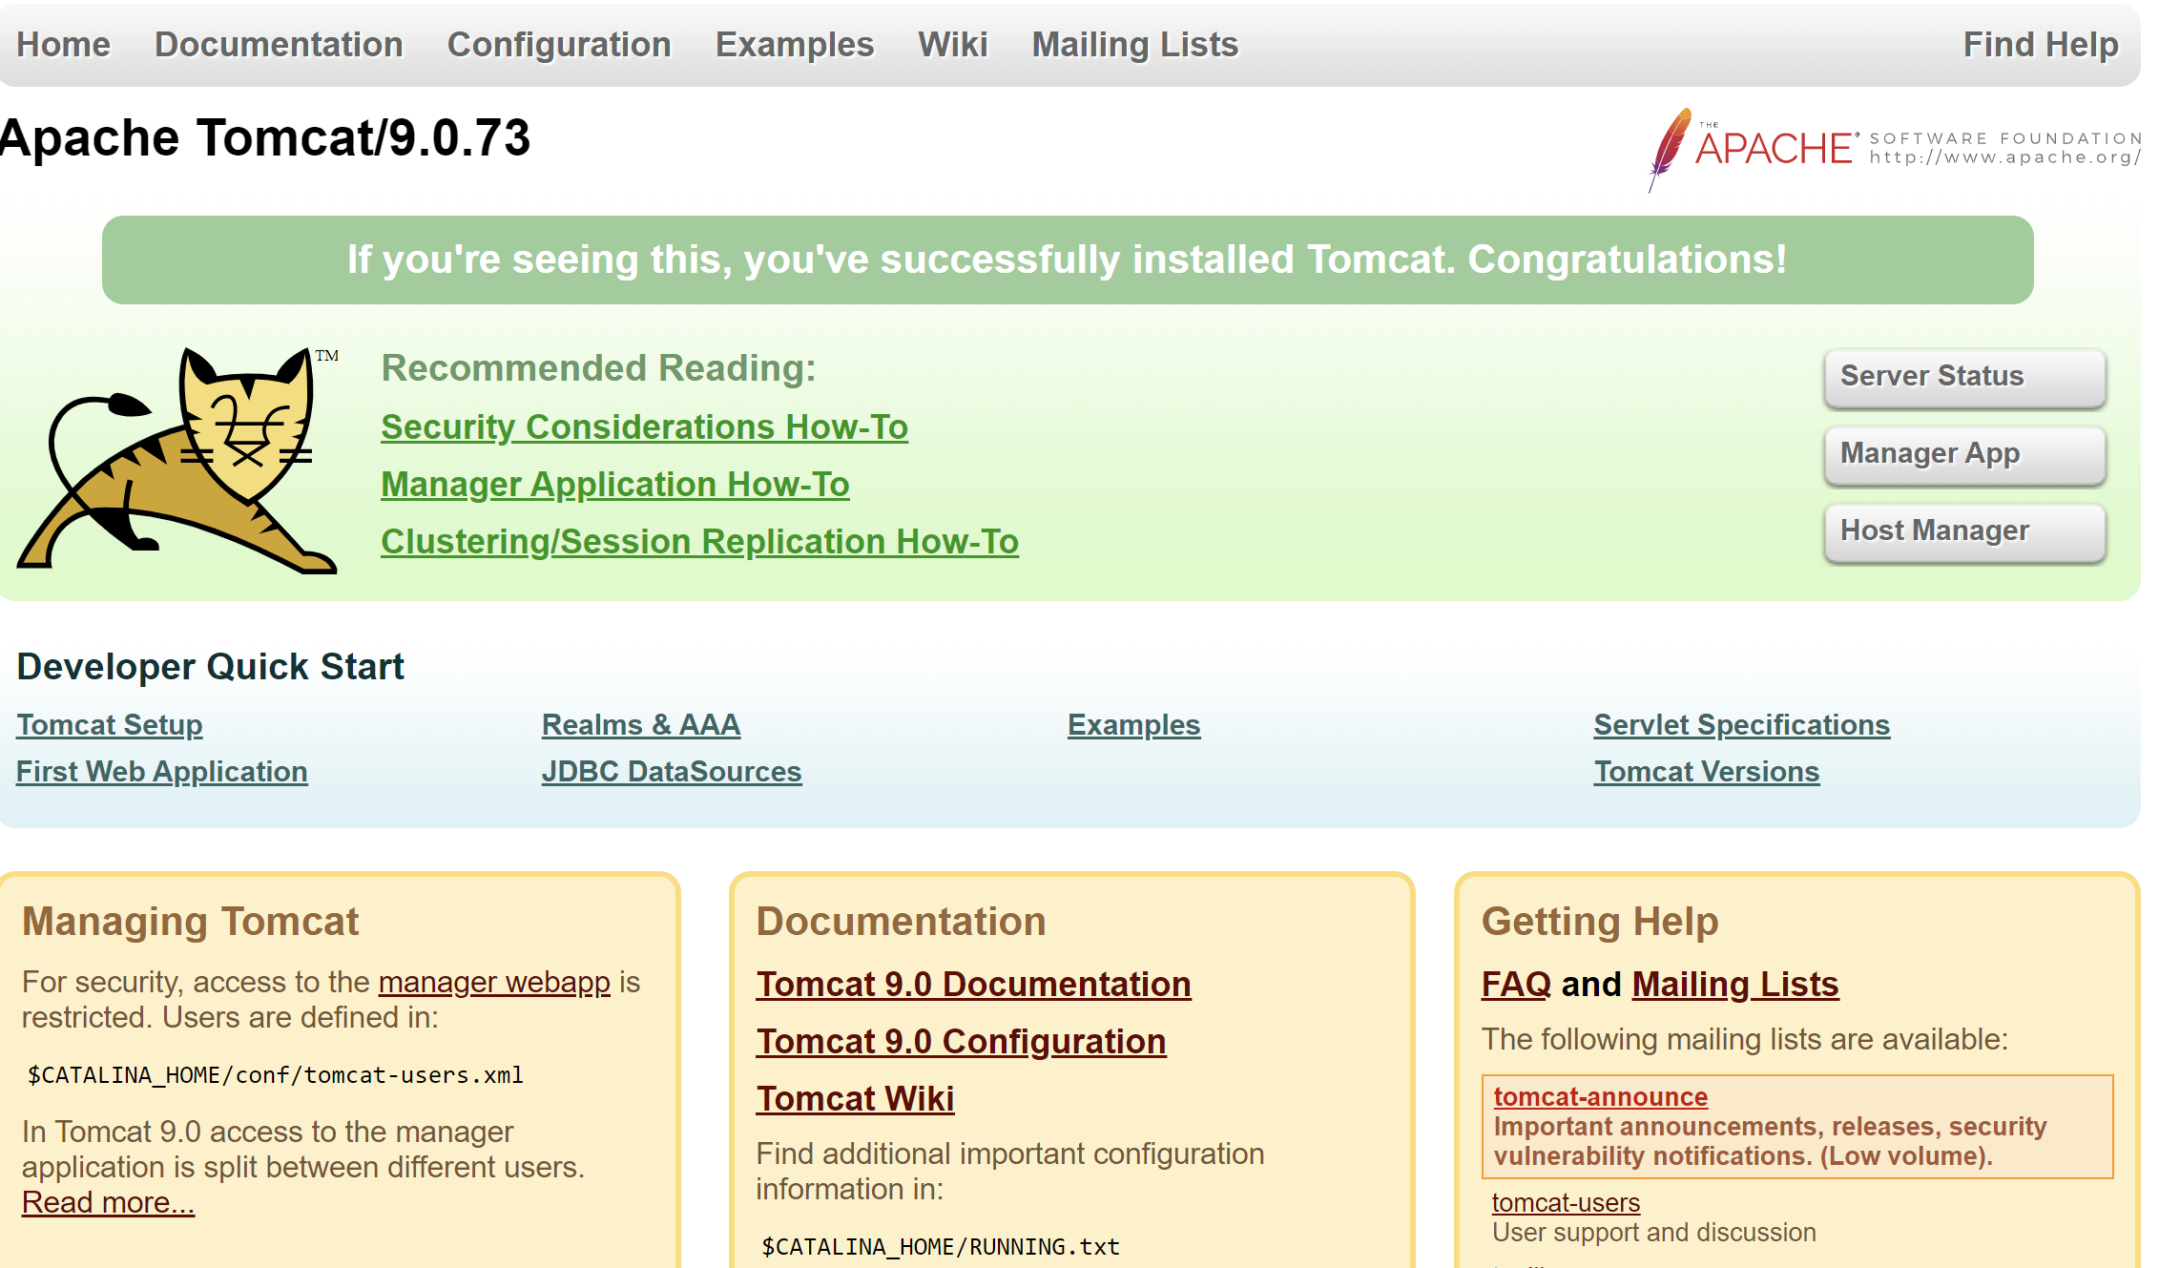

Go to manager app we get the unauthorized page because we can access tomcat web UI only from the machine’s browser where it is installed.

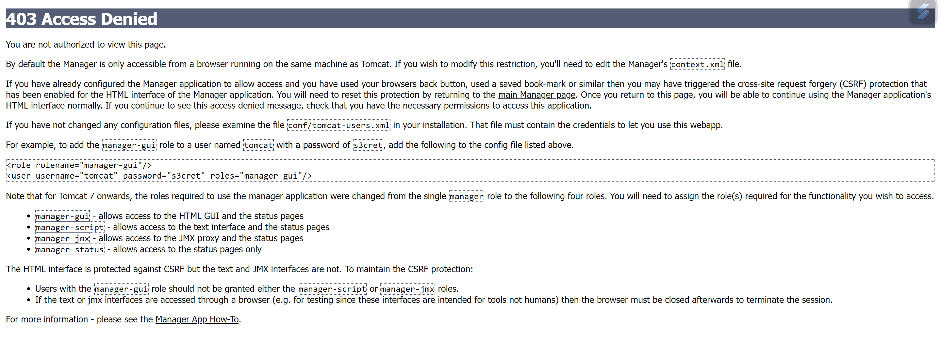

To make the web ui accessible from other browser we need to change context.xml, we need to make changes in these 2 context.xml:

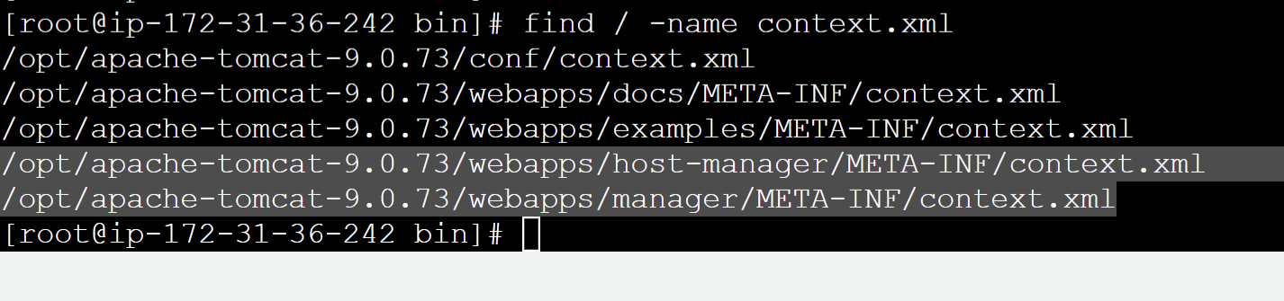

The changes should be commenting the line which is defined to connect from localhost or from the same server.

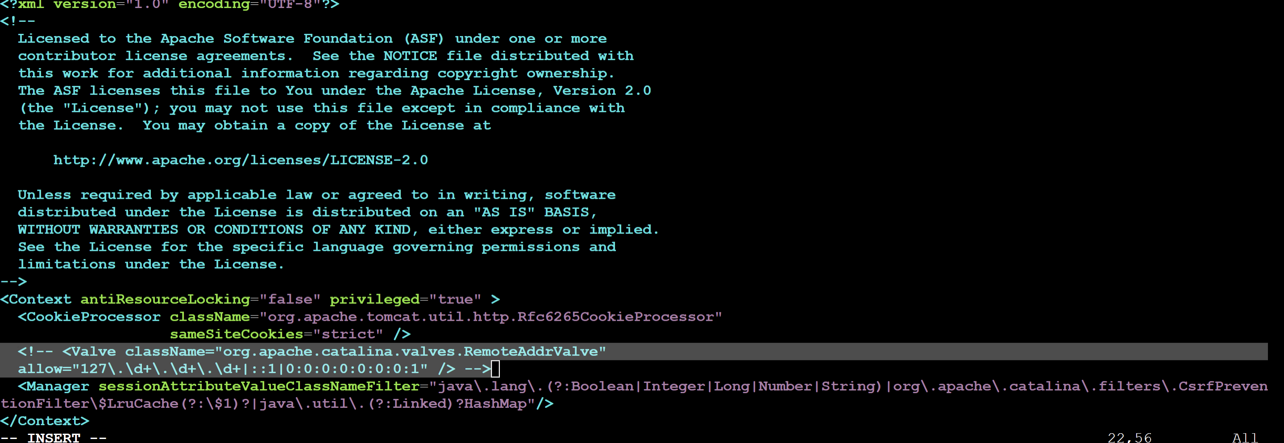

Restart tomcat server after making changes.

After going to manager apps it will ask for username,password.

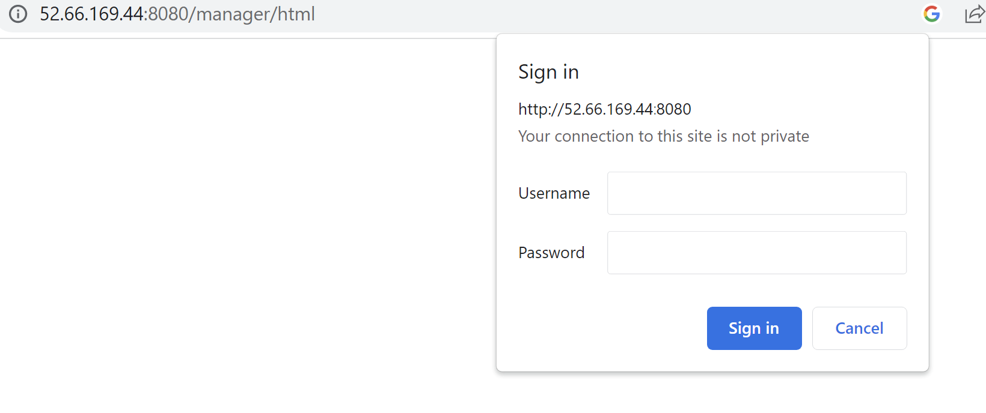

Edit tomcat-users.xml for adding username/password

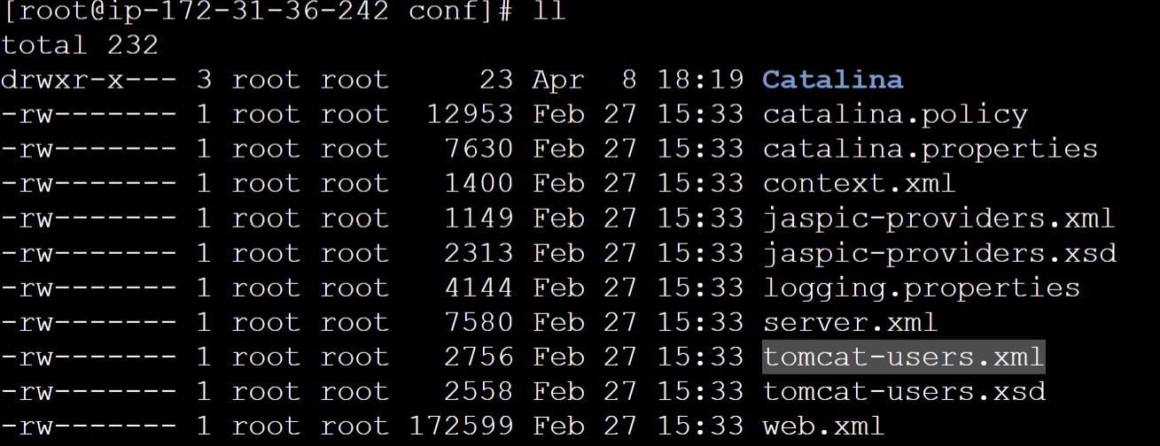

Edit the file as:

<role rolename="manager-gui"/>

<role rolename="manager-script"/>

<role rolename="manager-jmx"/>

<role rolename="manager-status"/>

<user username="admin" password="admin" roles="manager-gui, manager-script, manager-jmx, manager-status"/>

<user username="deployer" password="deployer" roles="manager-script"/>

<user username="tomcat" password="s3cret" roles="manager-gui"/>

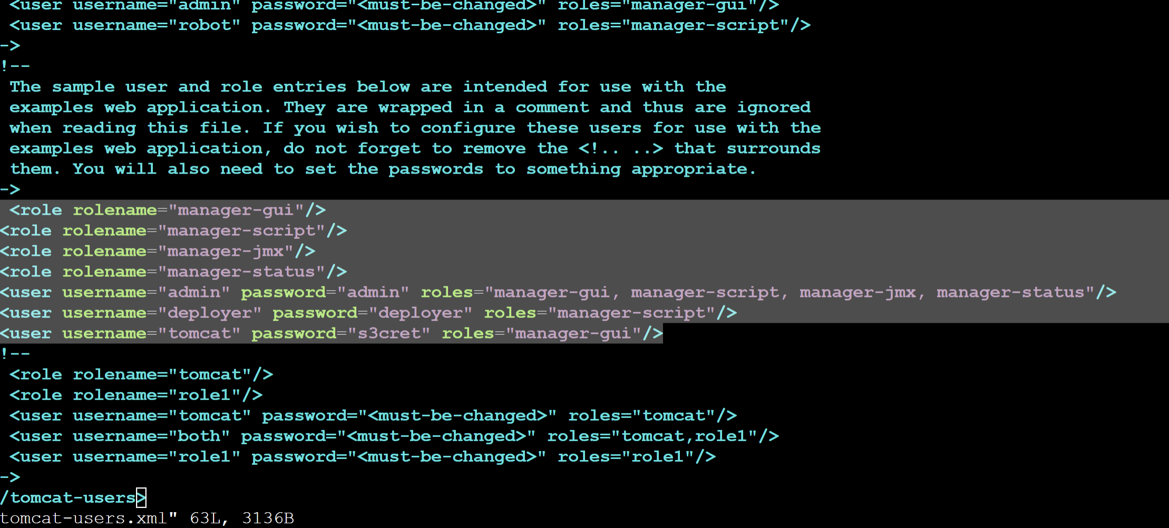

**Integrating Tomcat with Jenkins**

**Deploy to container** plugin to be installed to integrate tomcat server with Jenkins.

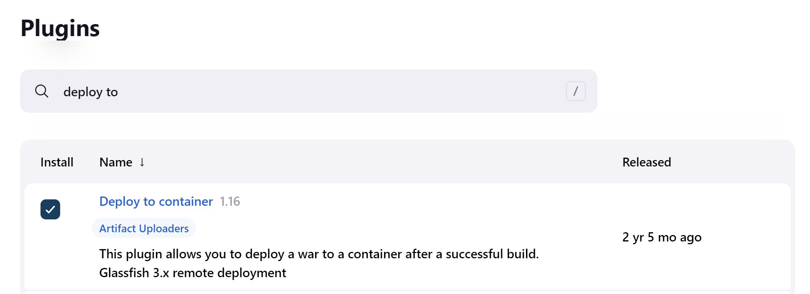

To manage Tomcat credentials we have to configure it in Jenkins as:

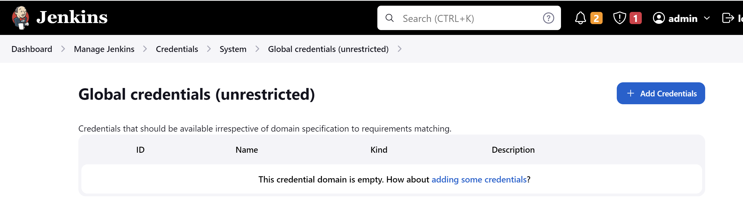

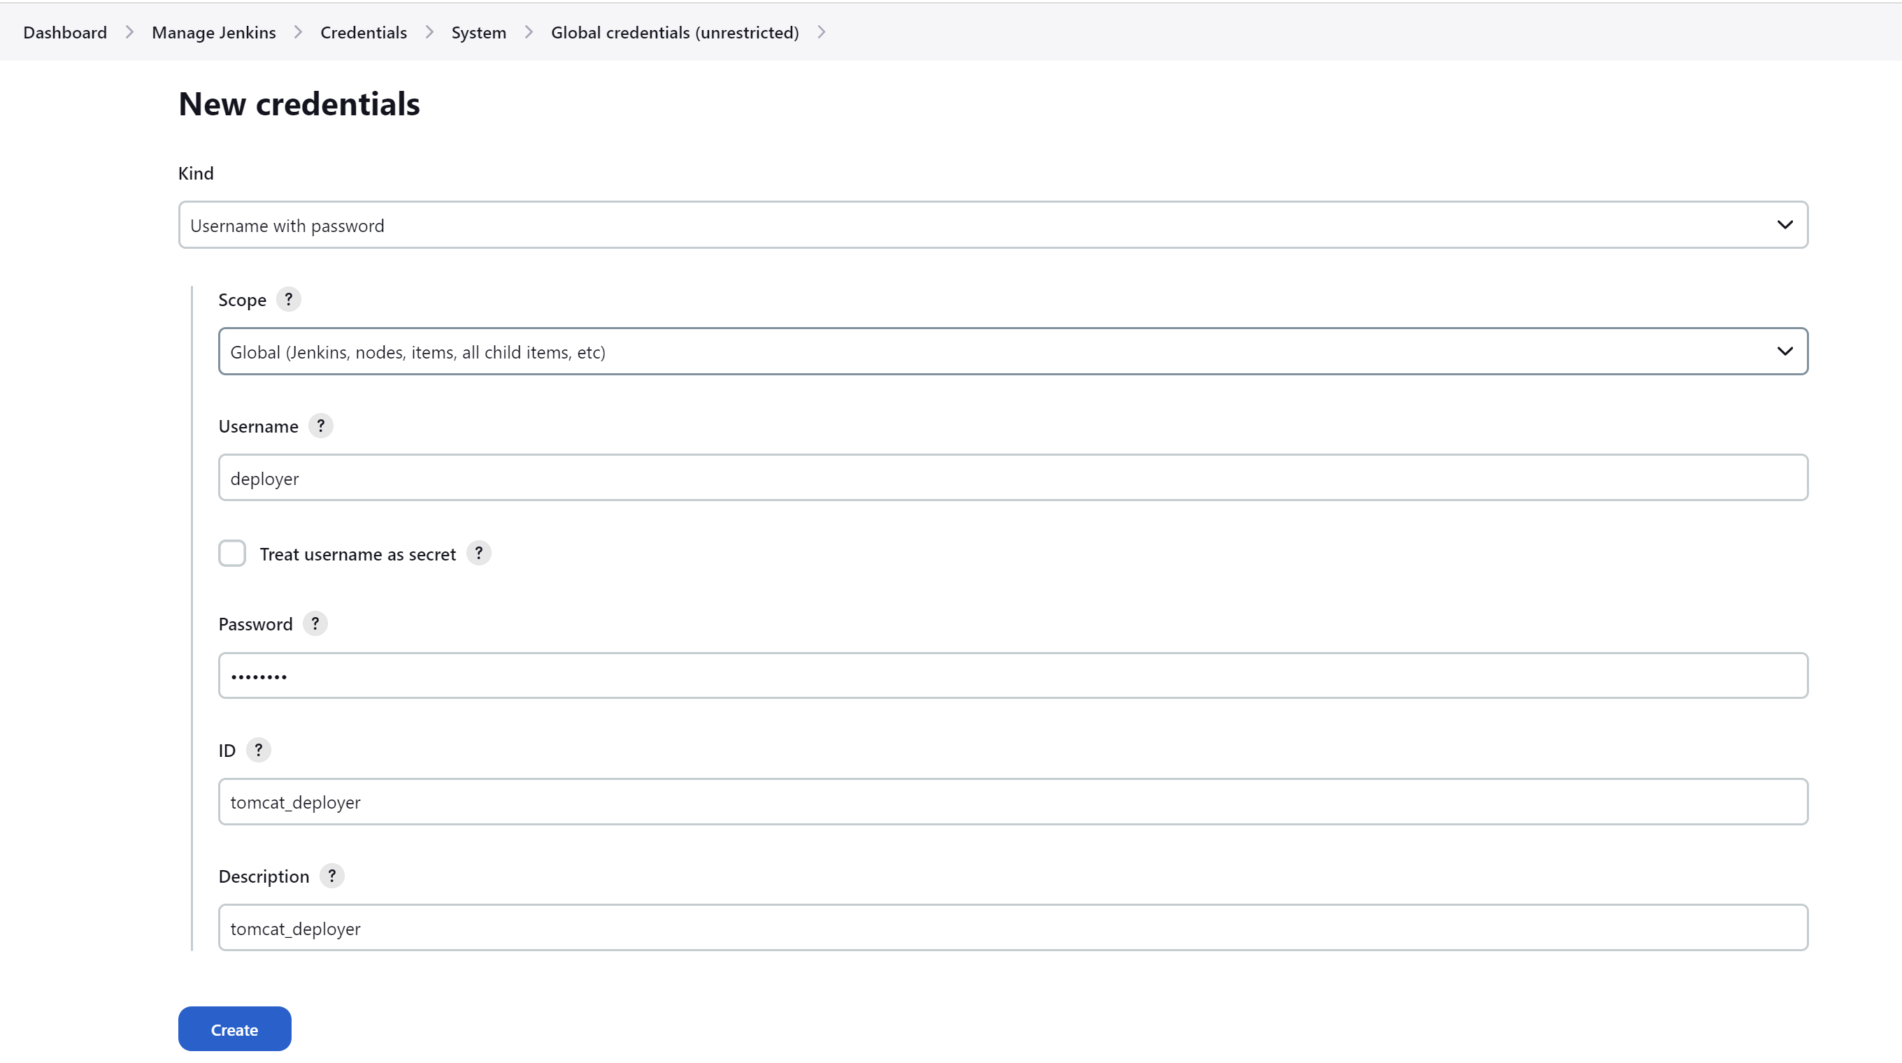

We will create another Jenkins project for “build and deploy” and will specify where the war is stored. In Jenkins war is stored at /var/lib/Jenkins/workspace/ as:

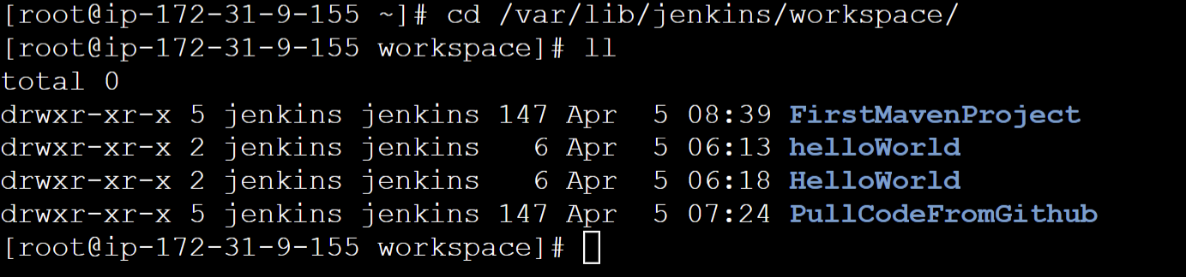

**\*\*/*.war** means any war file within our project directory in /var/lib/Jenkins/workspace/ourProjectName

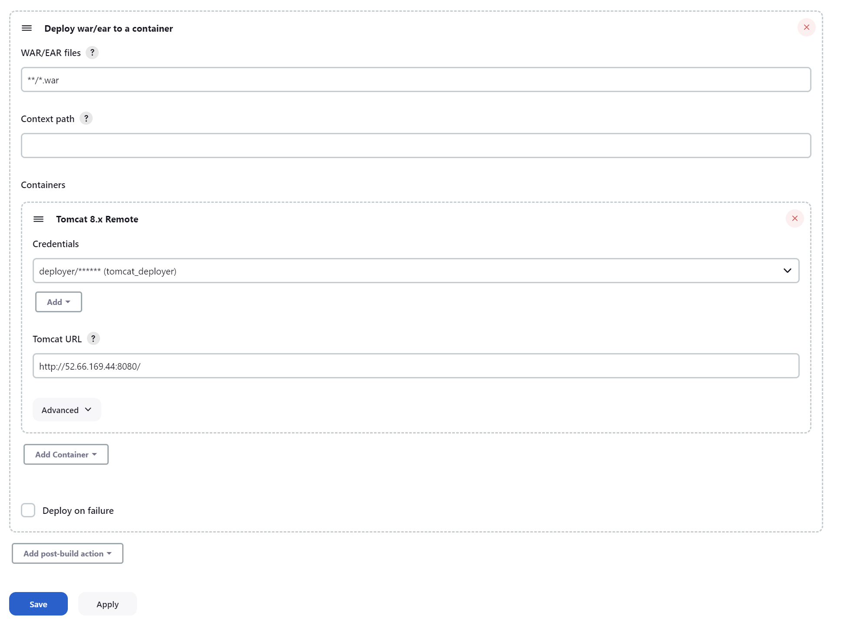

Before running our Jenkins job.

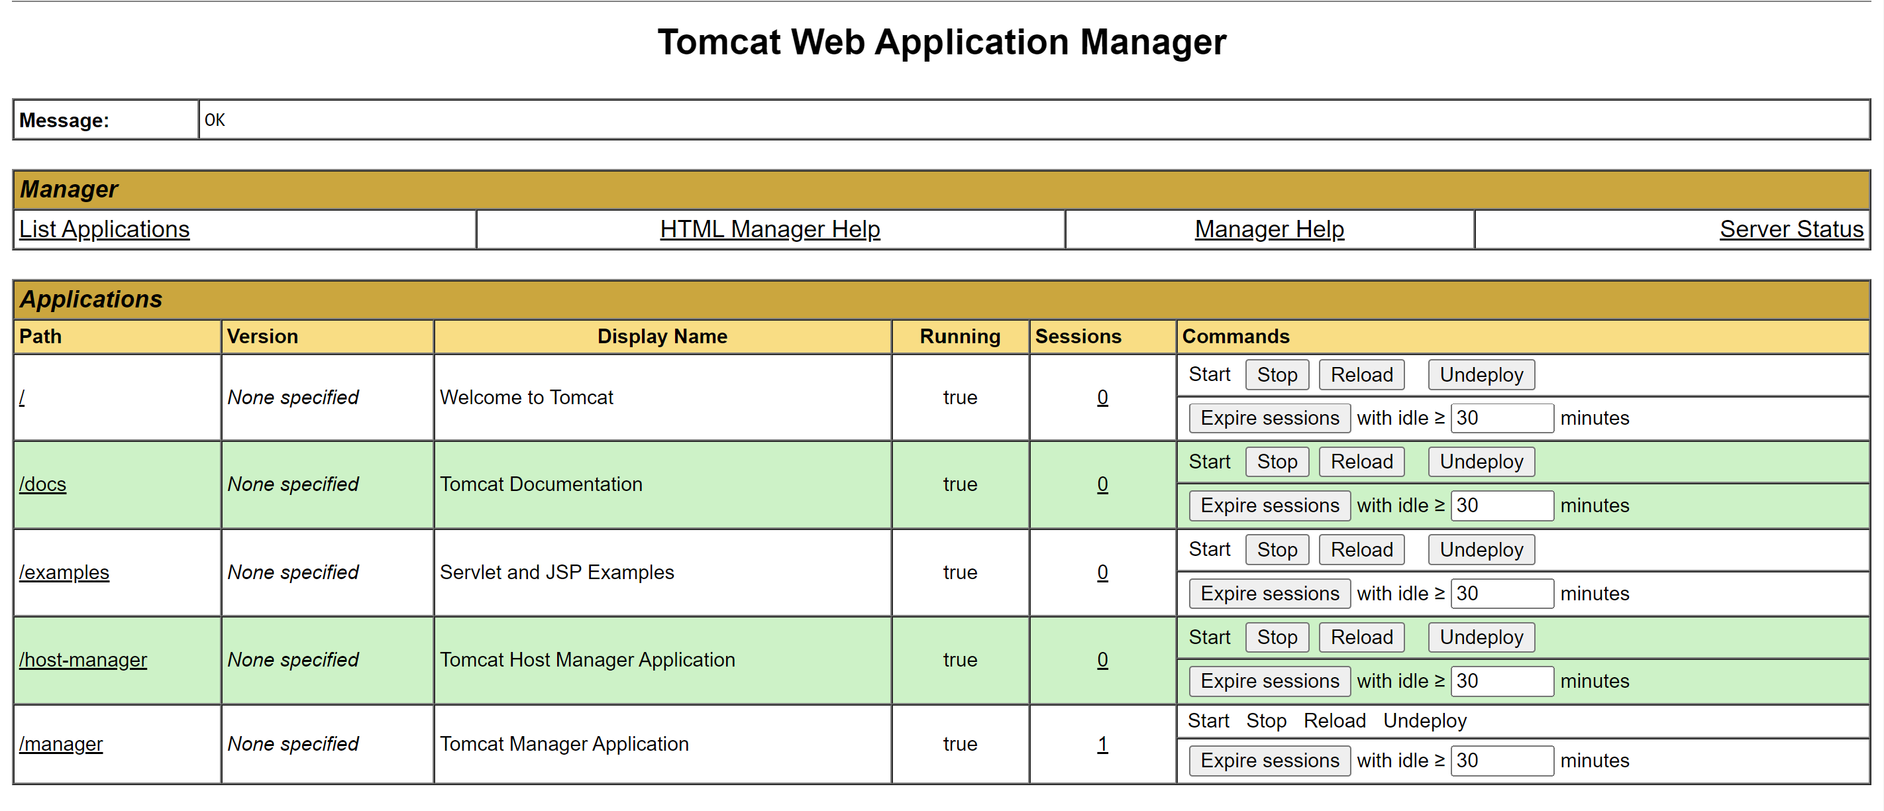

After running our Jenkins Job.

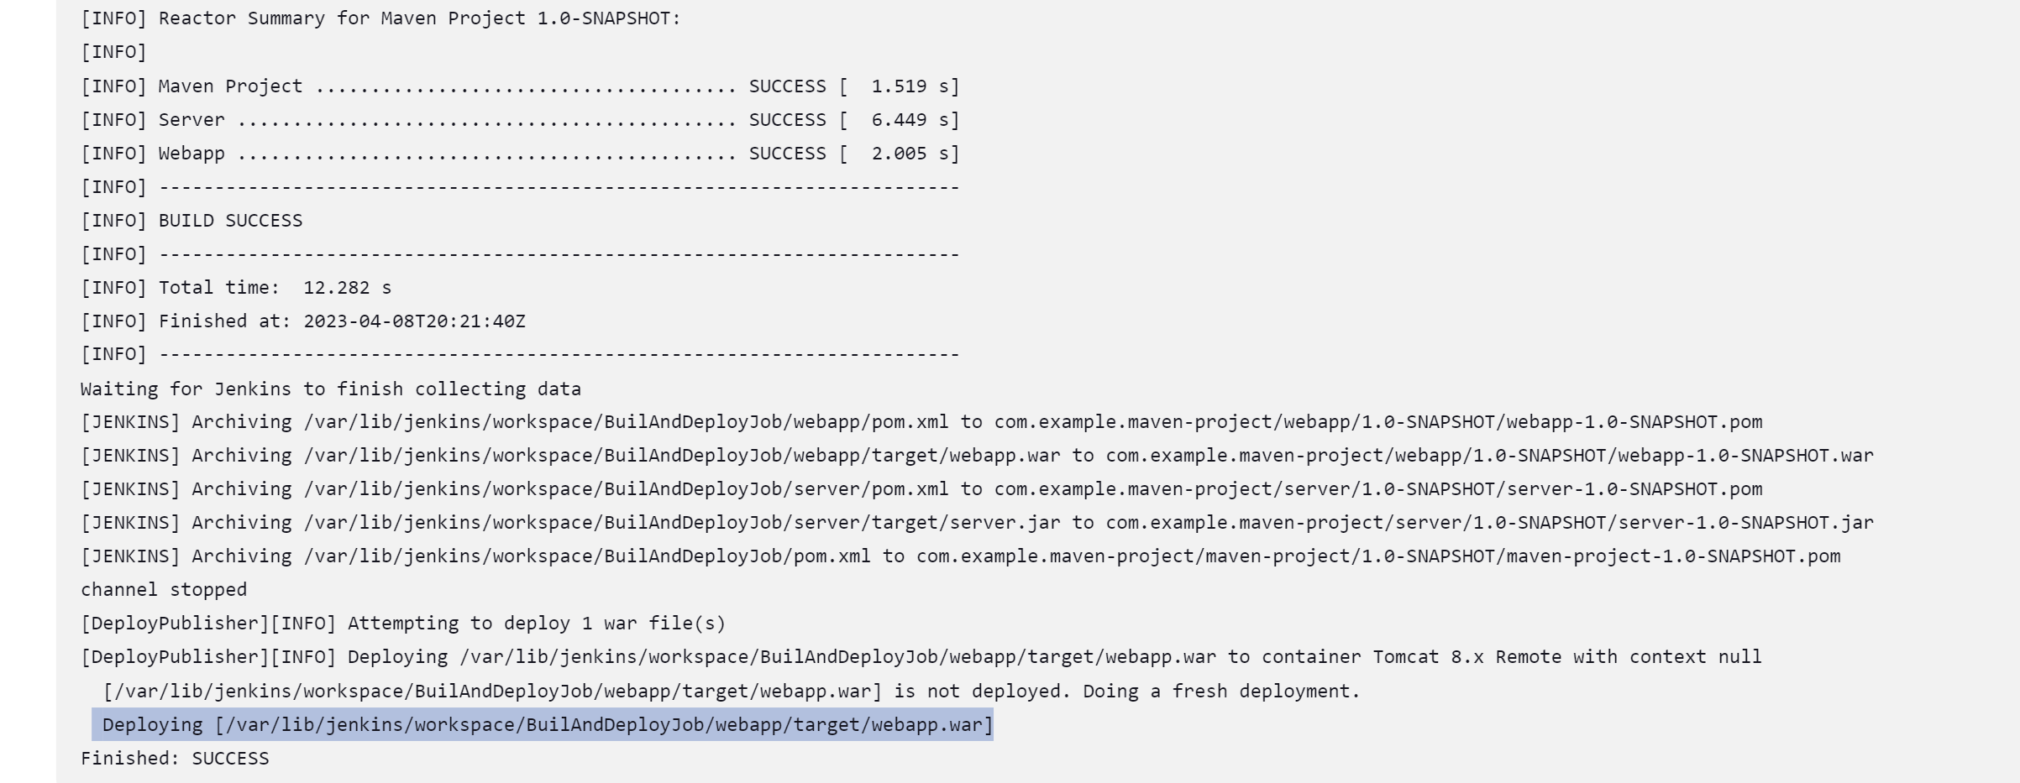

Webapp folder appears, clicking on /webapp will open our application.

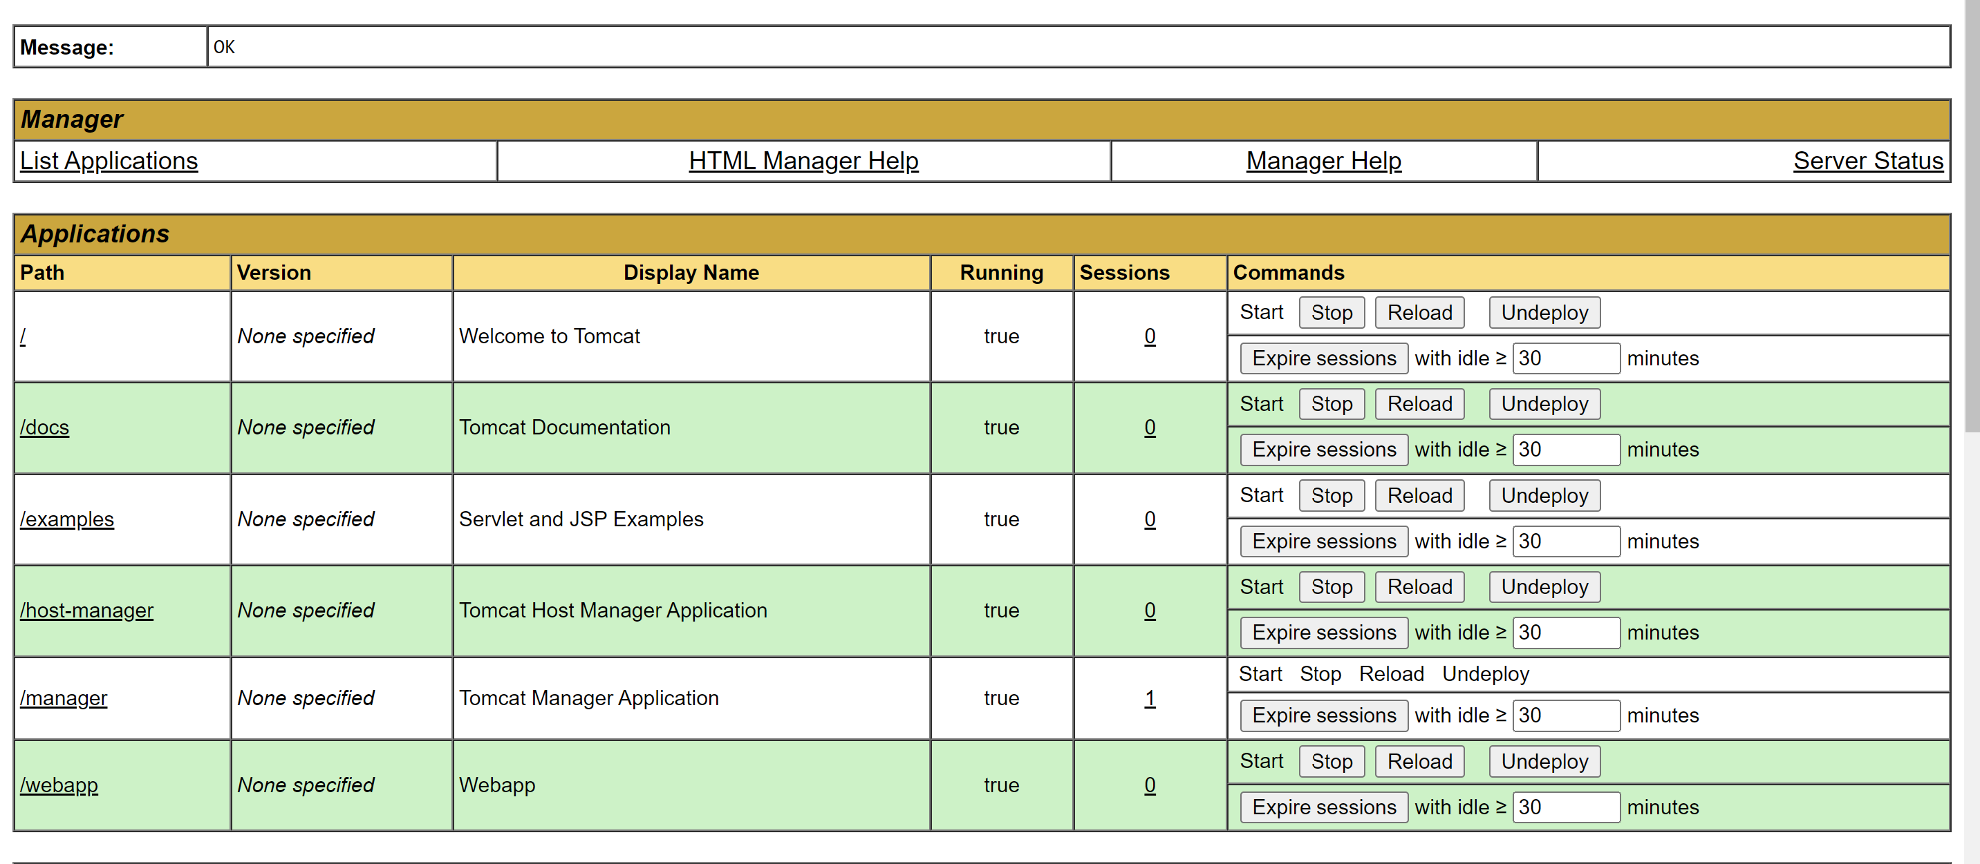

Automate deploy code when there is change in code in git.

In build Trigger option in Jenkins build for git we have to enable poll scm. Which will check for any change in git repository.

In git section:

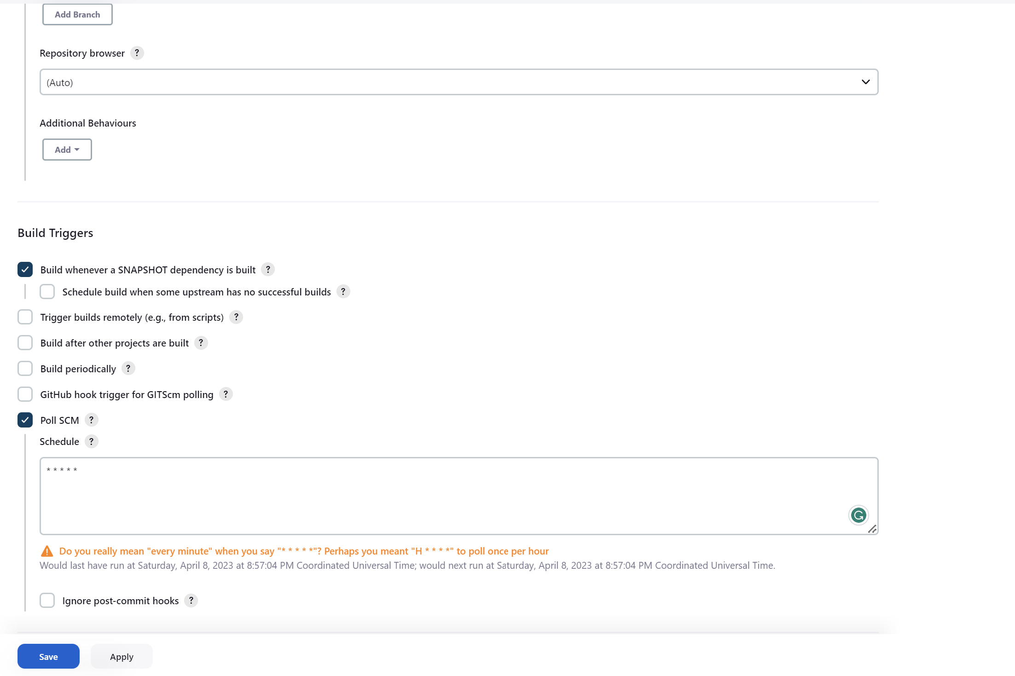

Whenever a new change is committed in git, it will be automatically picked and get deployed.

**Integrating Docker in CI/CD Pipeline:**

Create a **dockerHost** instance in aws ec2.

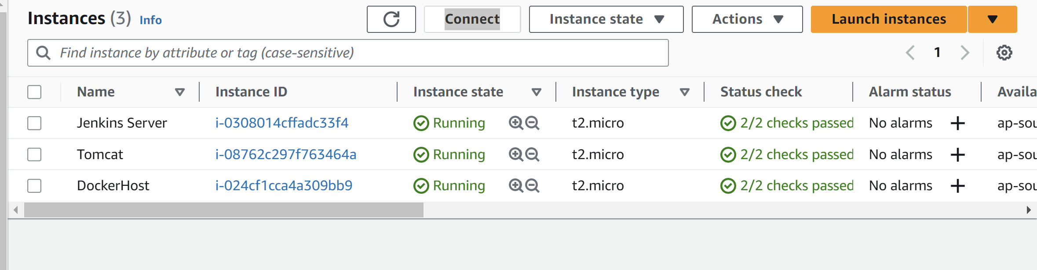

Install docker using : yum install docker

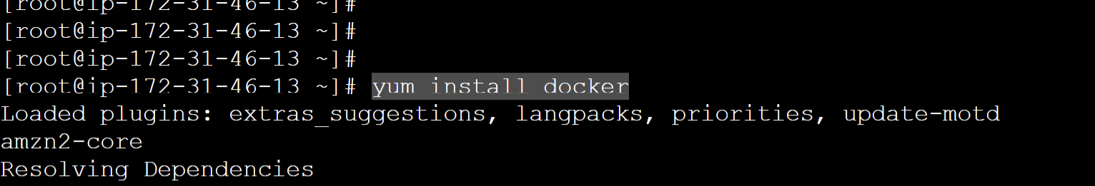

To start docker service: service docker start

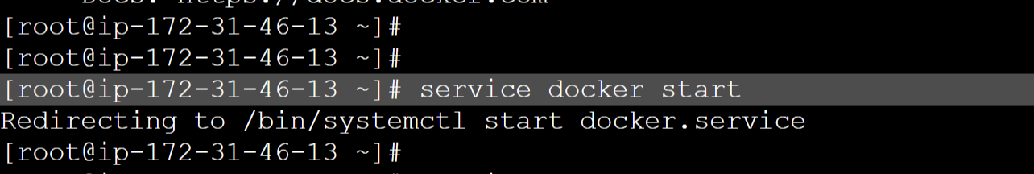

**Creating a Tomcat container:**

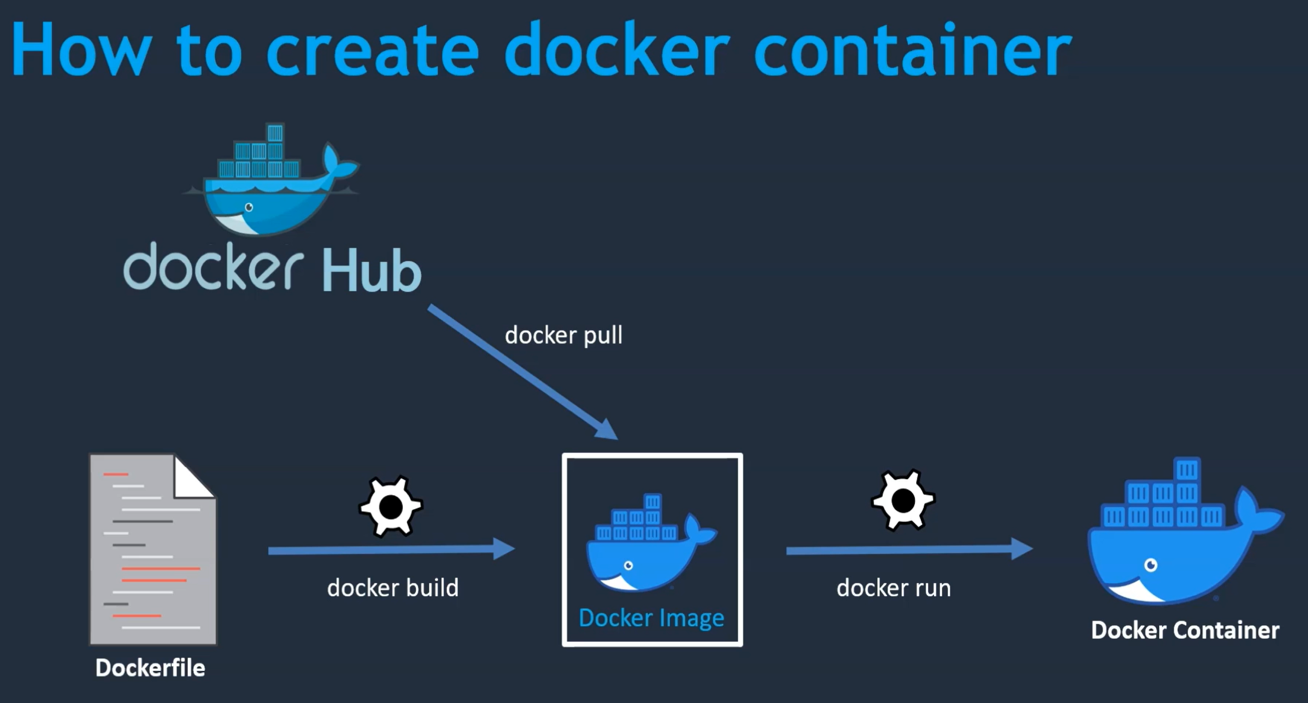

Get the docker image from **hub.docker.com**

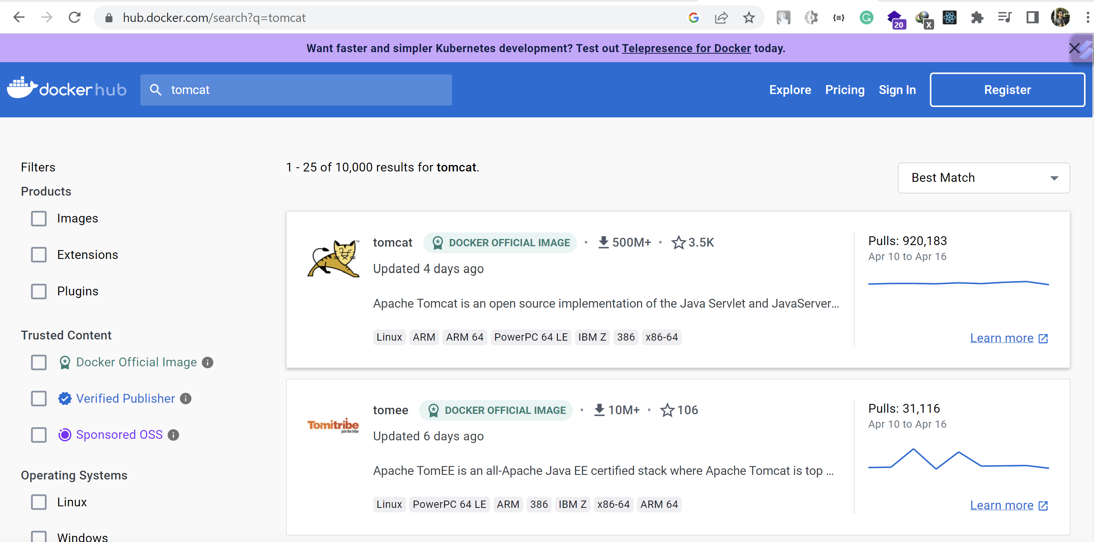

Copy docker command: **docker pull tomcat**

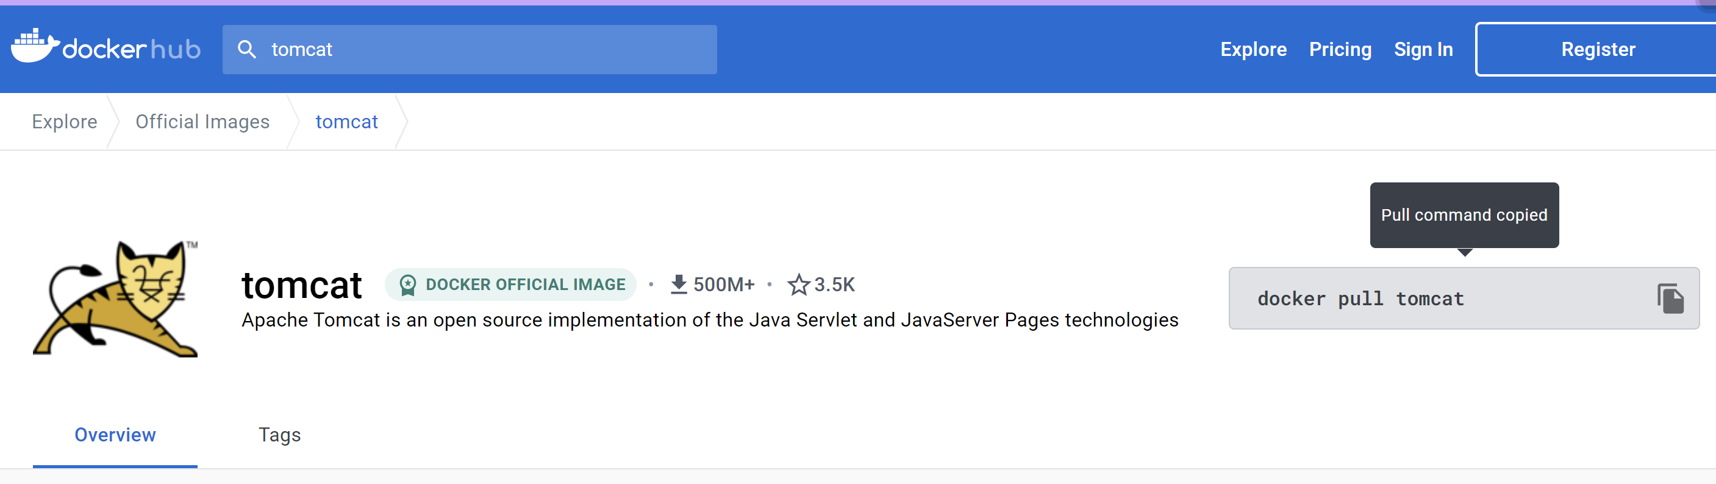

Pulling Docker image 🡪 It will pull latest tomcat image

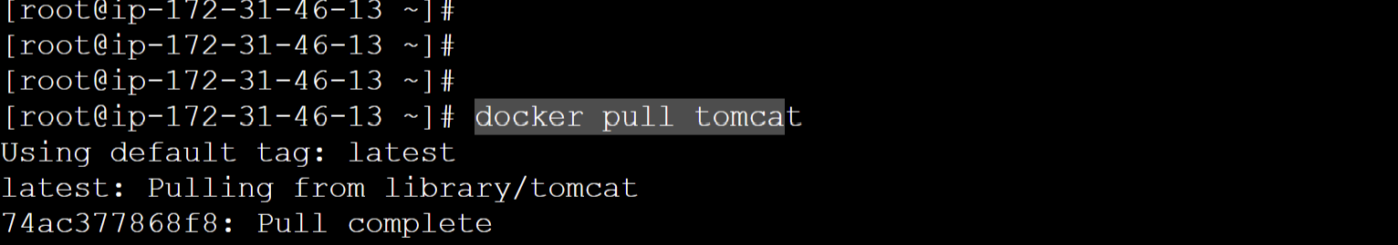

Some docker commands:

**docker images**

**docker ps 🡪** for running containers

**docker ps -a 🡪** all containers whether it is running one or stopped ones.

**docker start tomcat_container 🡪** To start any existing stopped docker container:

Running docker image as 🡪

**docker run -d --name tomcat-container -p 8081:8080 tomcat**

**-d:** detached mode

**-name tomcat-container:**  name of the running container will be **tomcat-container**.

**-p: 8081** is the port of docker which is mapped to tomcat port **8080**

**tomcat:** image name which will be run as a container.

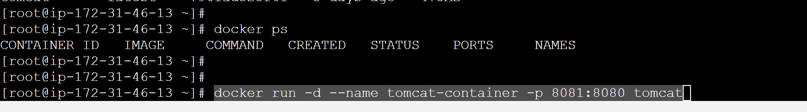

Running docker container:

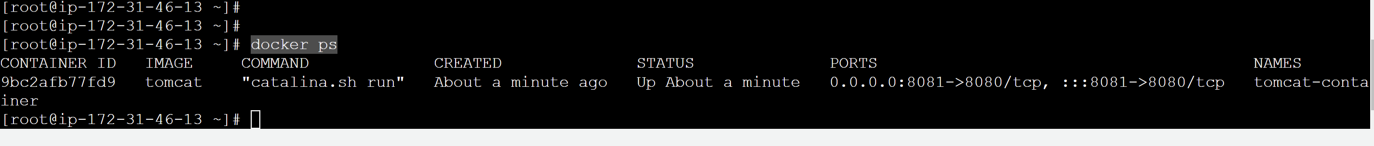

**Add inbound rules for port 8081**

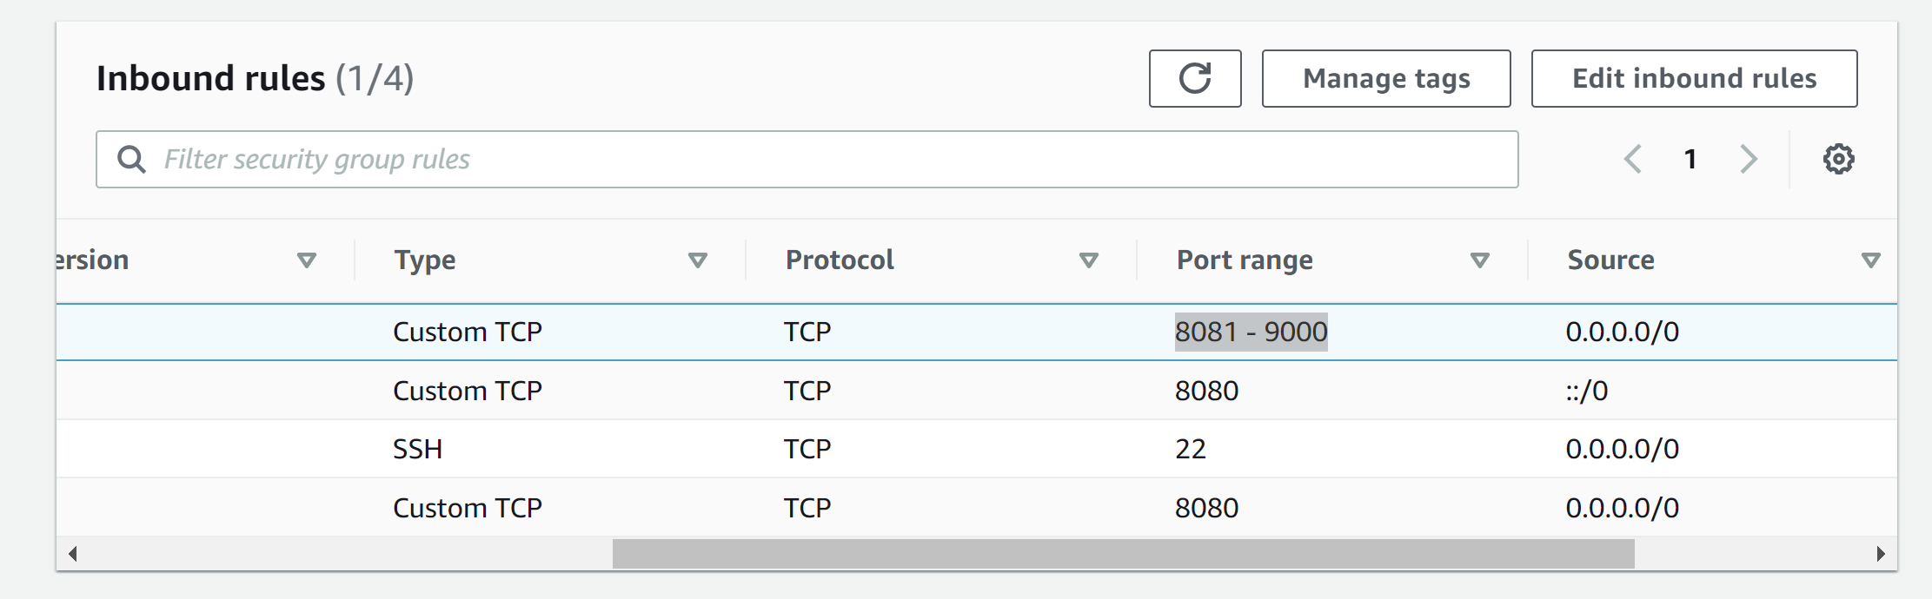

Open tomcat running on docker as:

**IpAddress:8081**

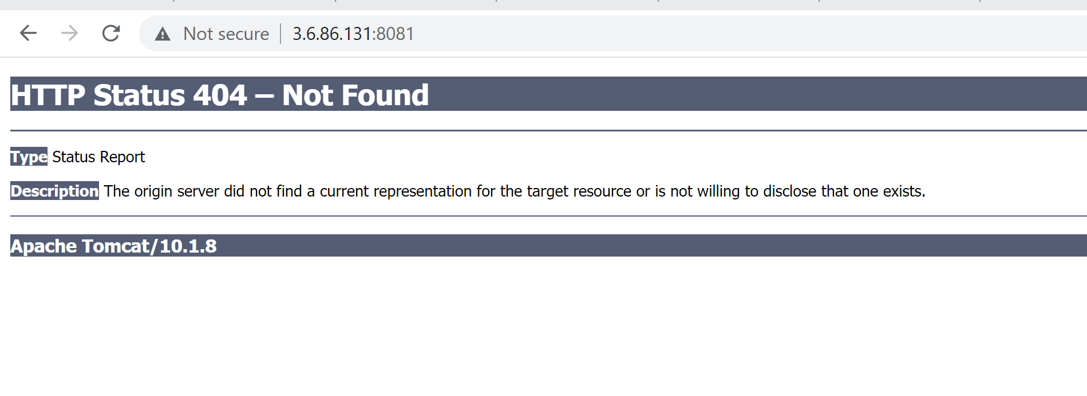

This error is happening because in tomcat container because it doesn’t have any files in webapps folder that is required to run the tomcat.

To go into container, we have the command 🡪 **docker exec -it tomcat_container /bin/bash**

, here we are logging in docker container tomcat_container with the help of /bin/bash.

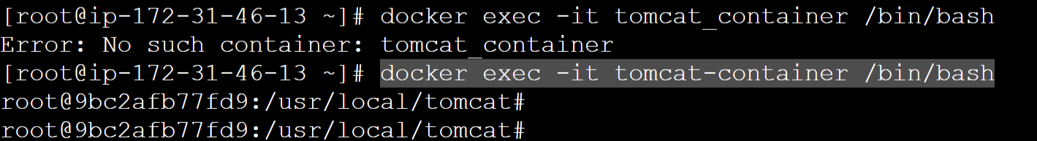

The error 404 was happening because in tomcat container because it doesn’t have any files in webapps folder that is required to run the tomcat.

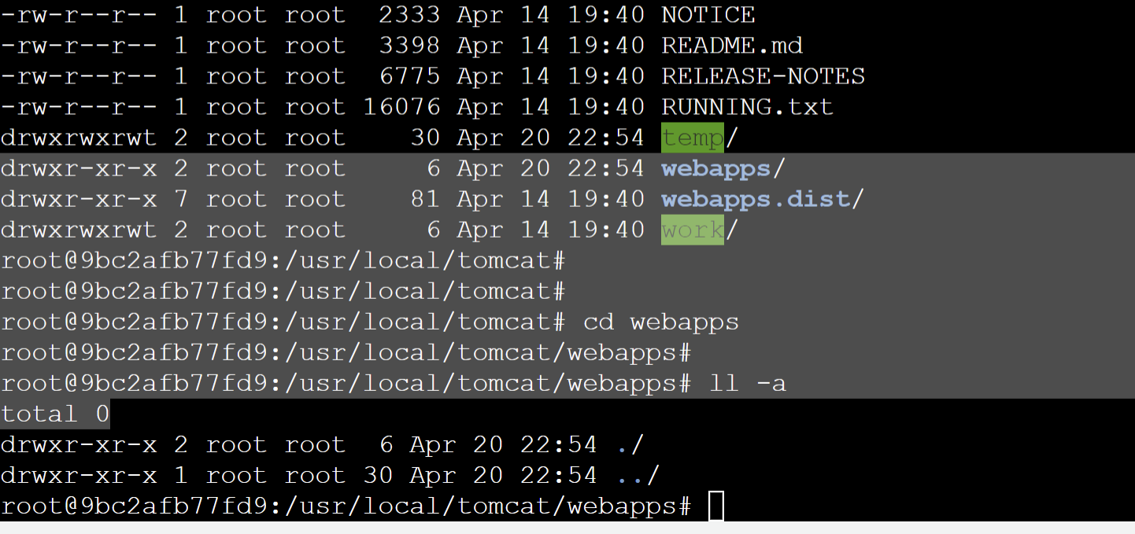

**Resolution:**

We have all the required files placed in **webapps.dist** folder.

To make our tomcat run successfully we have to move the contents from **webapps.dist** to **webapps**  folder.

1. **cd webapps.dist**
2. **cp -R * ../webapps**

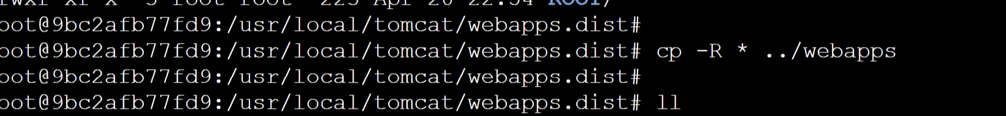

Again hitting the Ip for dockerHost

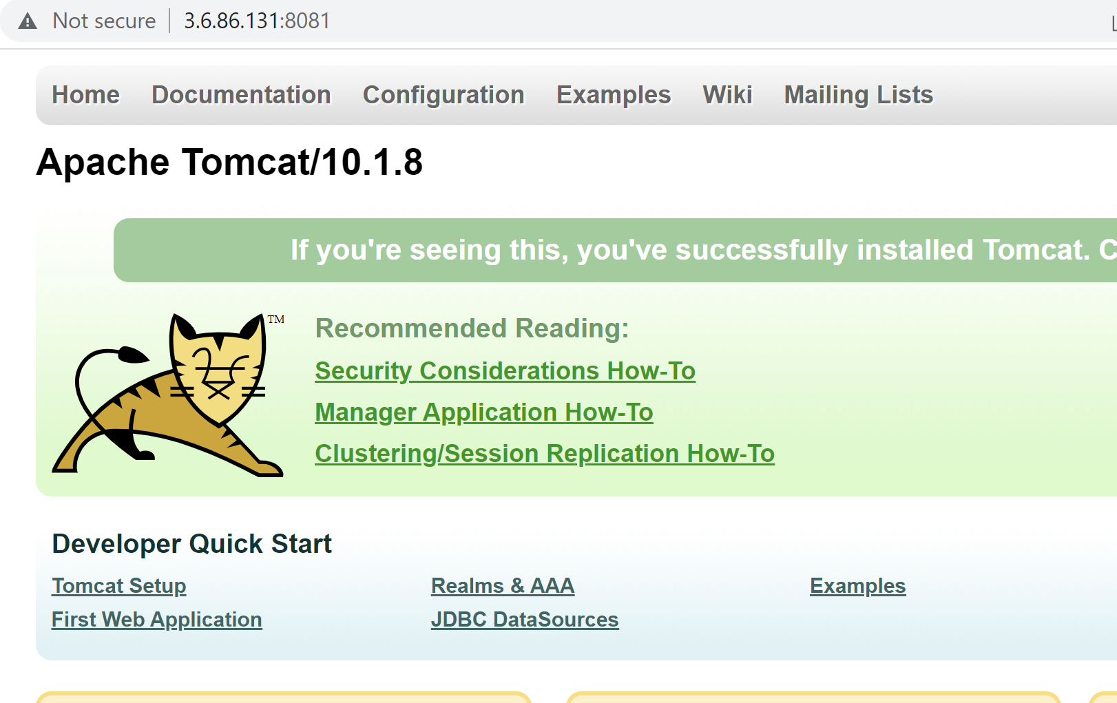

**Note->** As we made changes on specific docker container so, it will not be reflected to other docker container using similar image. So, if we want to have new docker container from the image then we will not be having these changes present in new container. For that reason we use **dockerfile.**

The docker file pulls the docker image and contains additional information and commands which need to be performed.

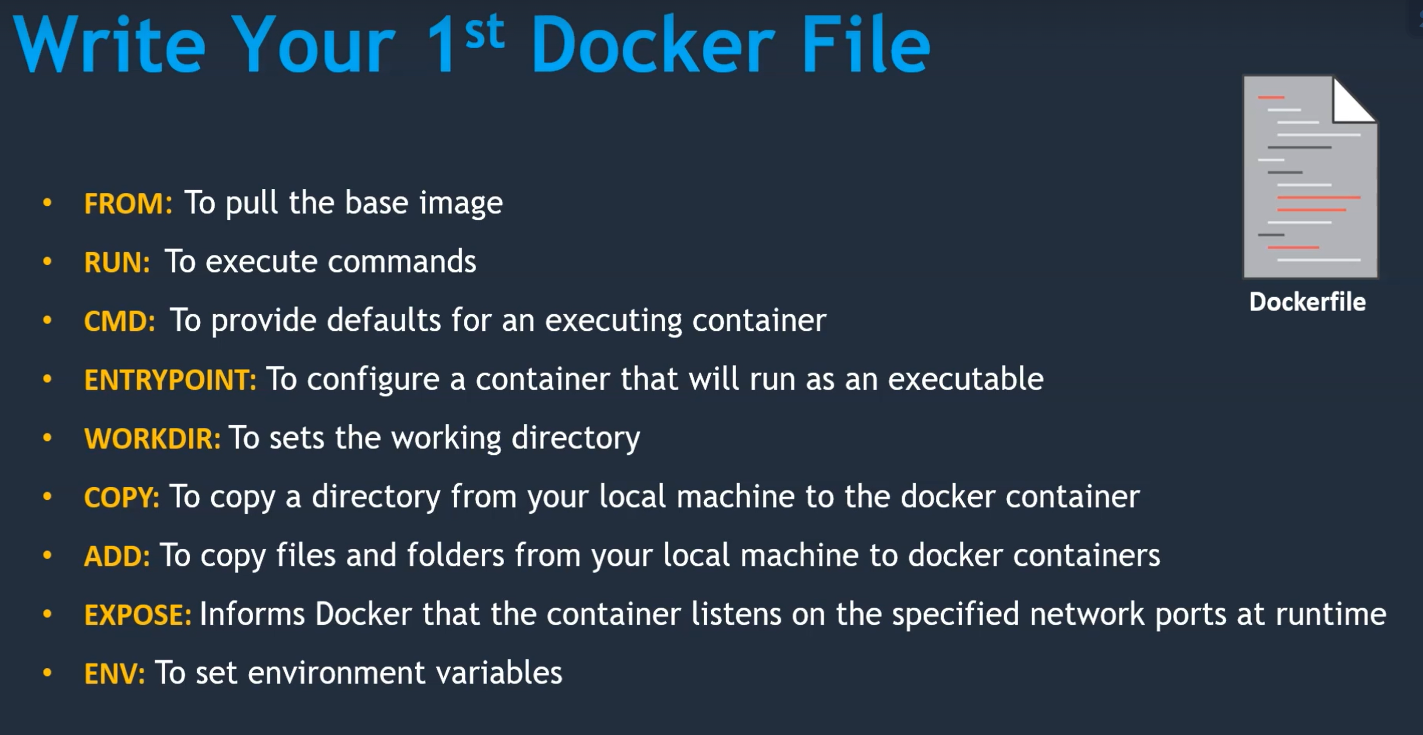

Sample docker file instructions to Install Tomcat on CentOS.

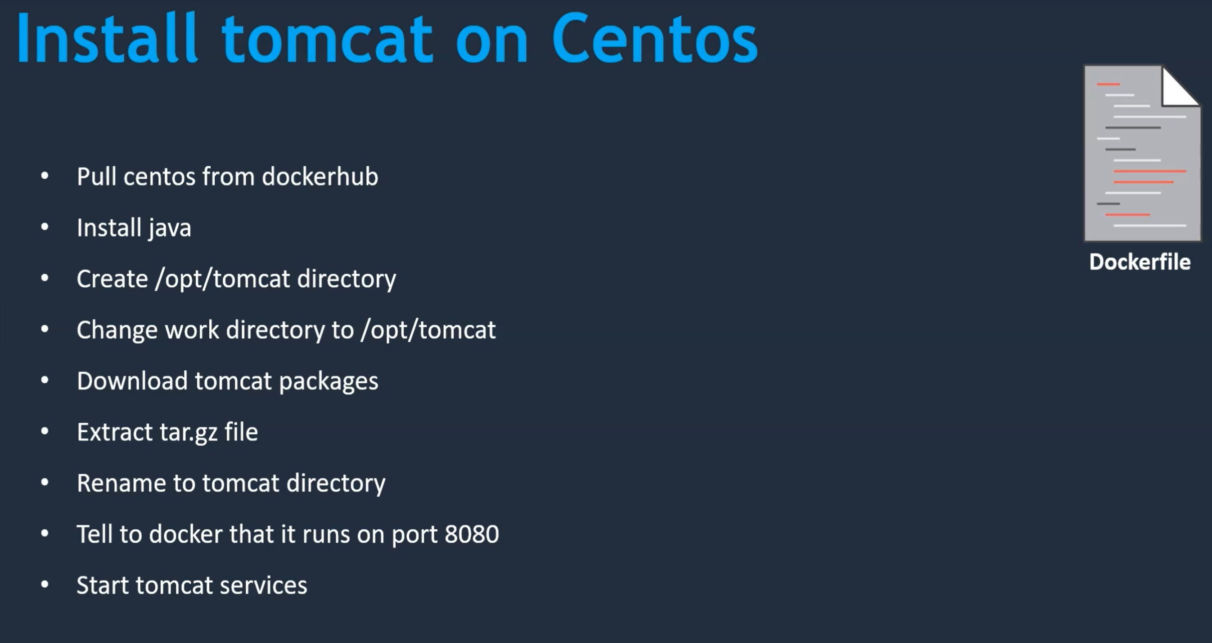

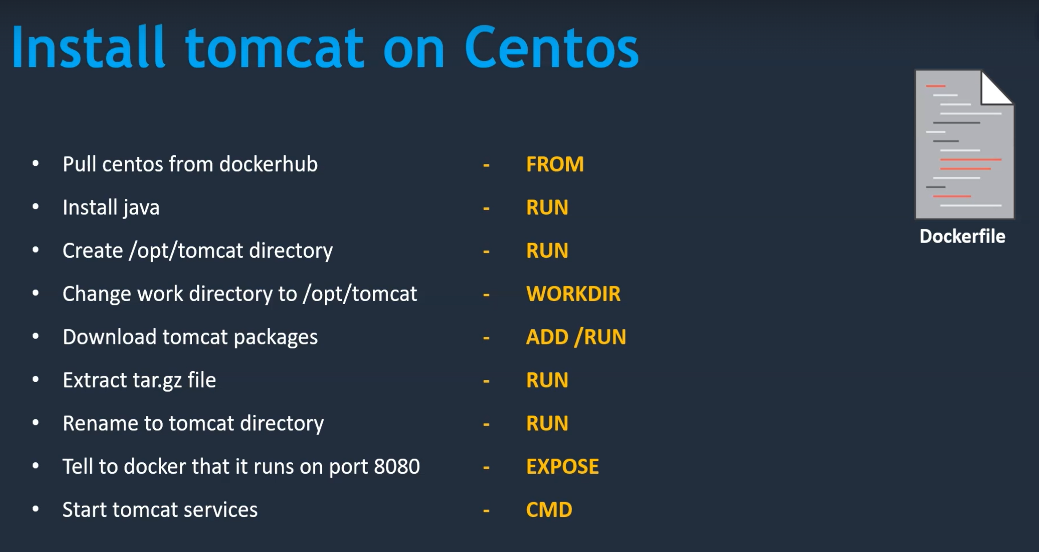

**Now creating a docker file.**

vim Dockerfile

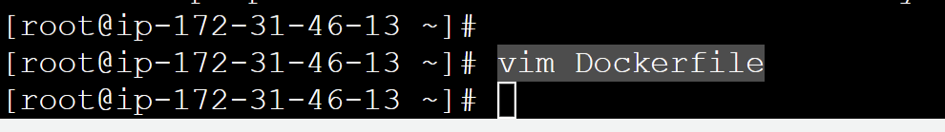

**Paste the content into Dockerfile:**

From centos:7

RUN yum install java -y

RUN mkdir /opt/tomcat

WORKDIR /opt/tomcat

ADD https://dlcdn.apache.org/tomcat/tomcat-9/v9.0.74/bin/apache-tomcat-9.0.74.tar.gz .

RUN tar -xvzf apache-tomcat-9.0.74.tar.gz

RUN mv apache-tomcat-9.0.74/* /opt/tomcat

EXPOSE 8080

CMD ["/opt/tomcat/bin/catalina.sh", "run"]

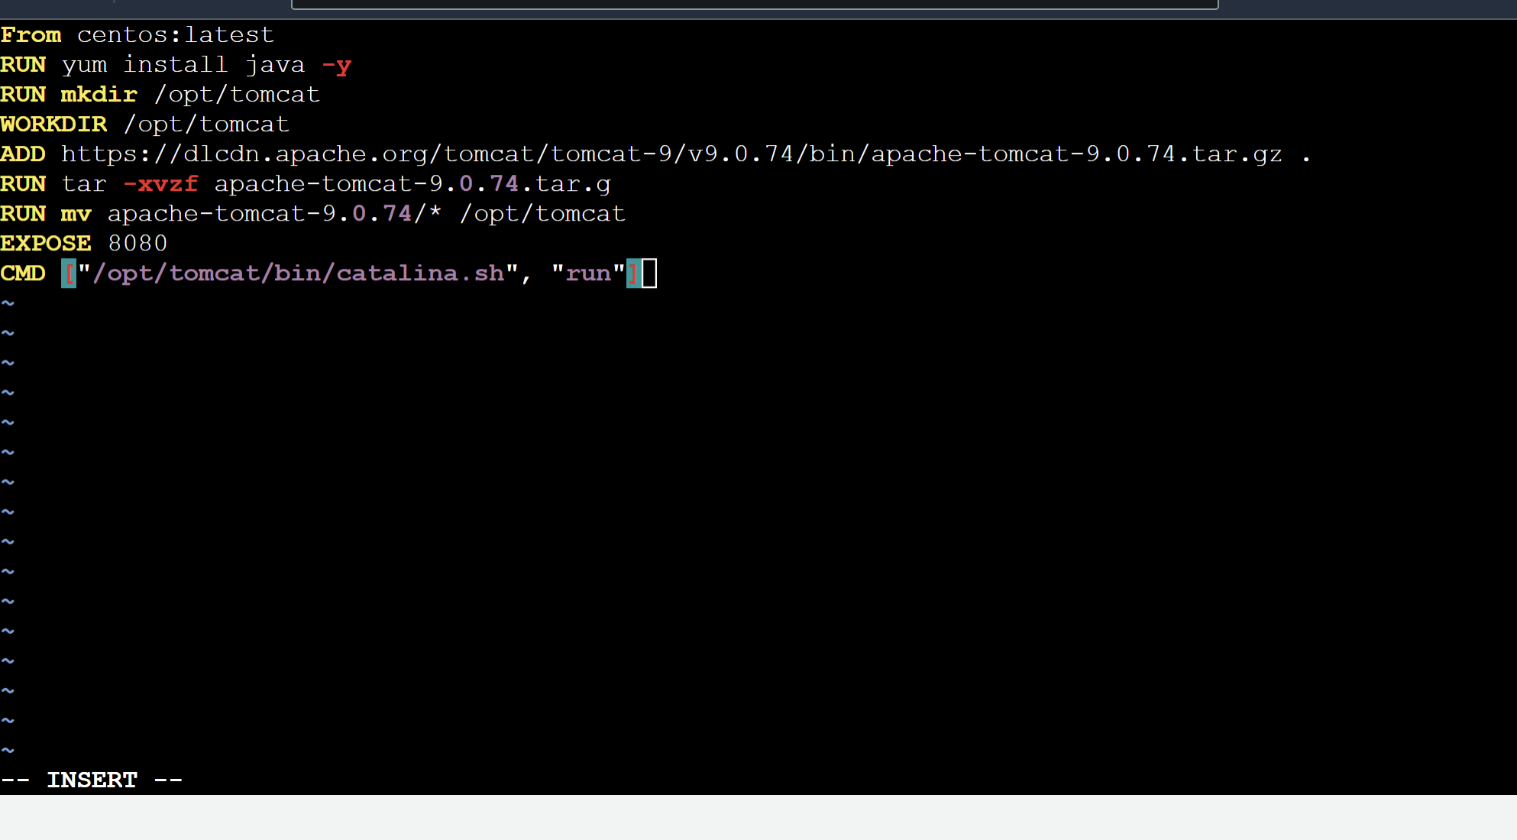

**Now create an image for the dockerfile 🡪**

Using command 🡪 **docker build -t mytomcat .**

Here we are building an image from dockerfile present in current directory represented by (**.**) with tagname as mytomcat.

Changed to centos:7 as the latest version causing issue as : “Error: Failed to download metadata for repo 'appstream': Cannot prepare internal mirrorlist: No URLs in mirrorlist”

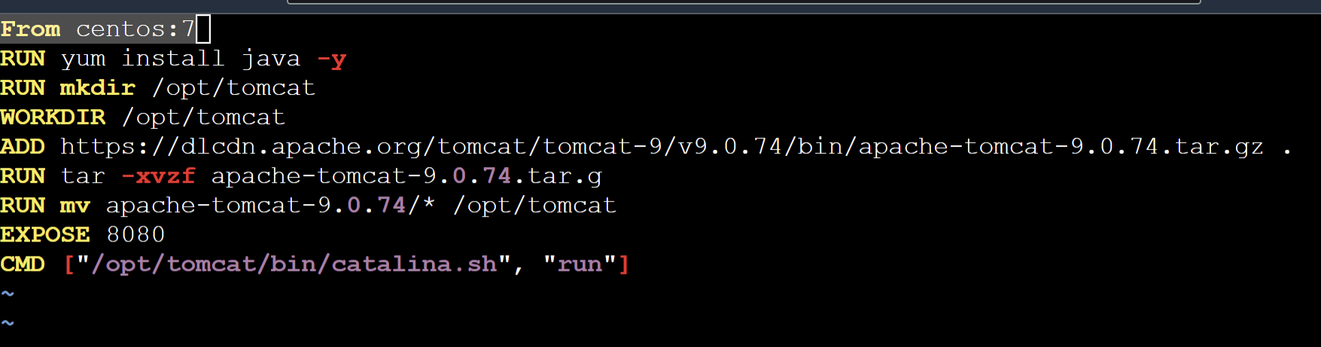

After building the image

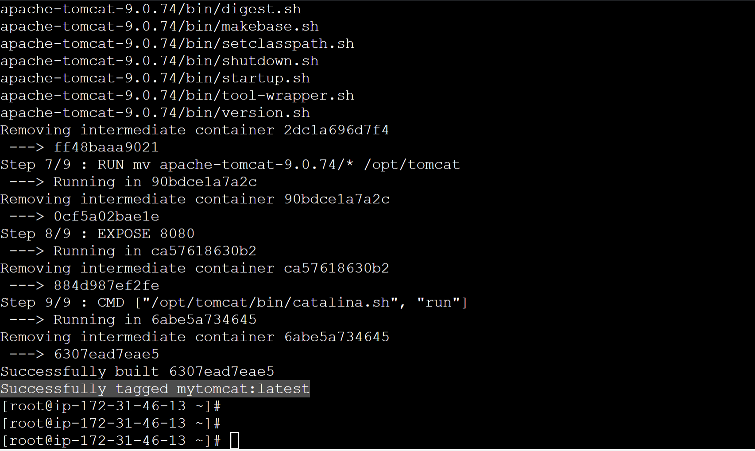

**Docker images** command also gives us our own created image.

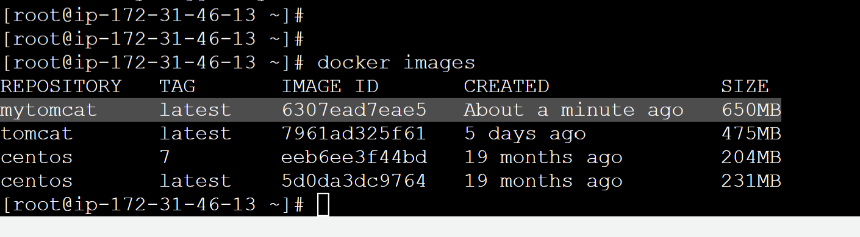

Run the container on port 8083

**docker run -d --name mytomcat-container -p 8083:8080 mytomcat**



have already added port 8083 in inbound rules in security group for the dockerHost instance to access the port 8083.

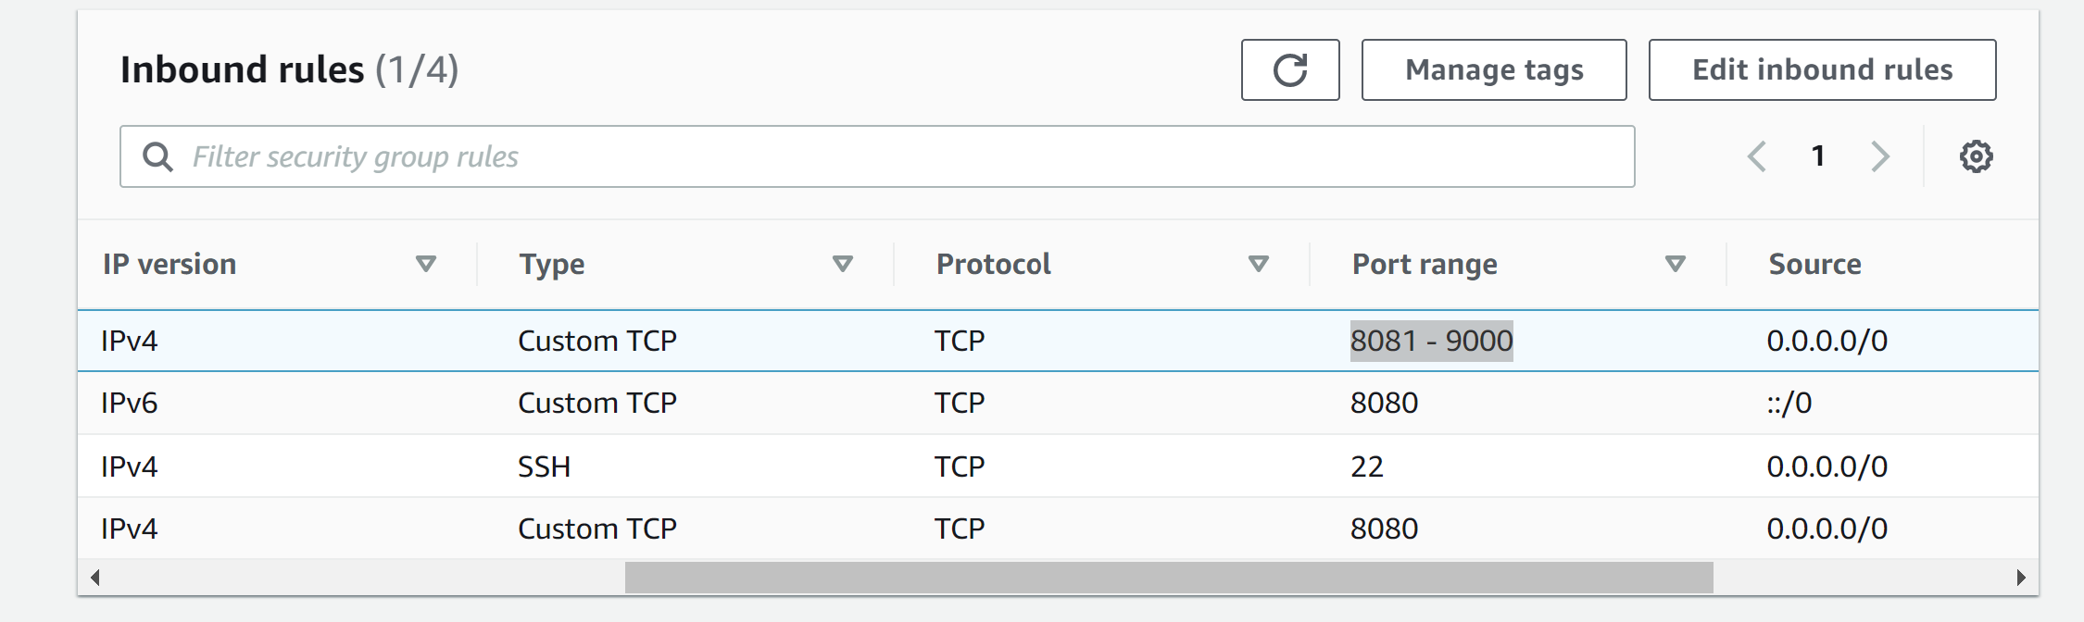

Hitting the ip at port 8083, we get the tomcat running.

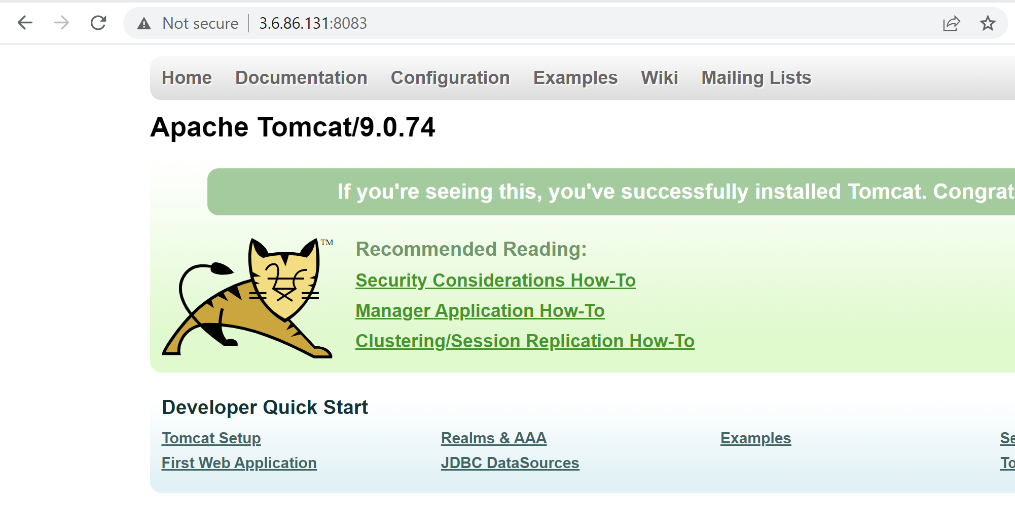

**Creating Cutomized Dockerfile for Tomcat image.**

Removing existing docker file 🡪 rm DockerFile or rename earlier Dockerfile and creating new one.

**FROM tomcat:latest**

**RUN cp -R /usr/local/tomcat/webapps.dist/* /usr/local/tomcat/webapps/**

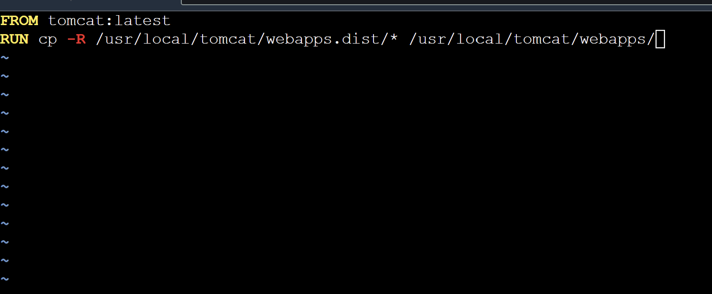

Now creating a docker image from it:

**docker build -t tomcat-customized .**

run this image as:

**docker run -d --name tomcat-customized-container -p 8085:8080 tomcat-customized**



Run tomcat on port 8085.

**Integrating docker with Jenkins**

Create a dedicated user for dockerHost. We can ec2-uses but creating a new user is recommended.

**cat /etc/passwd**  command gives list of user present.

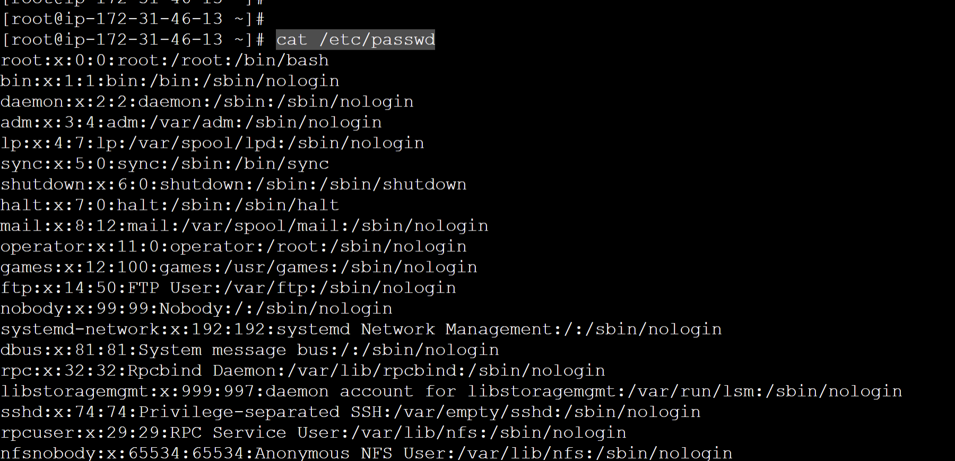

**cat /etc/group** command provides all group present.

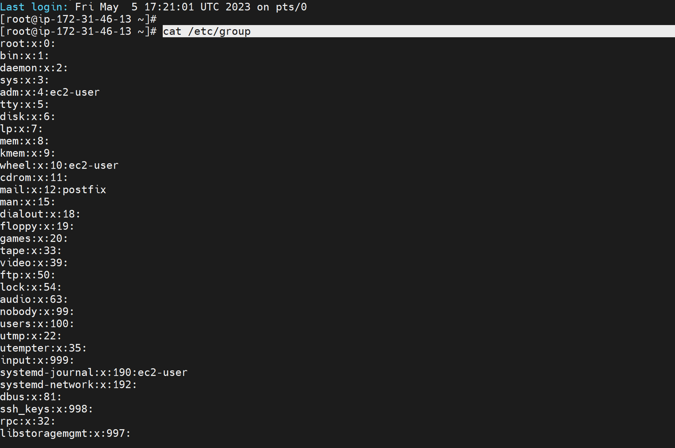

Command to add new user -> **useradd dockeradmin**

To add password for it 🡪 **passwd dockeradmin**  it will prompt to enter password.

Here we set our password to **dockerpwd**

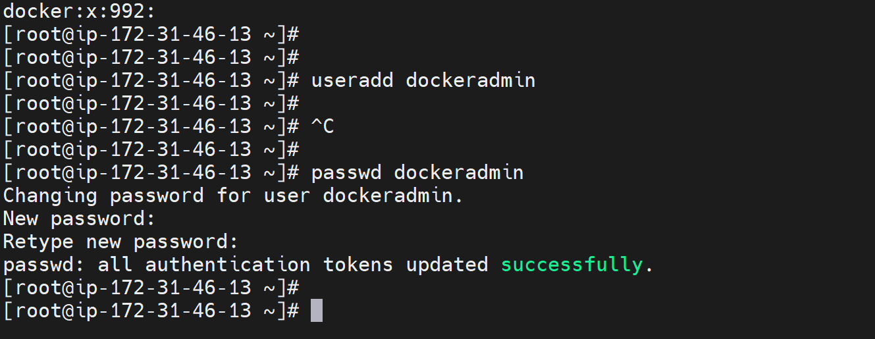

To list the group where our dockeradmin is currently in 🡪 **id dockeradmin**

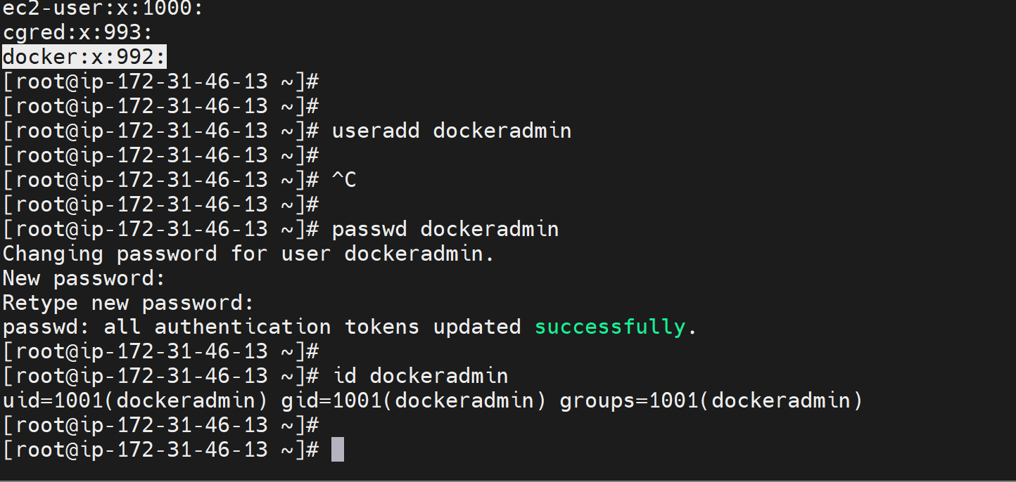

We have to add this user in group 992(docker).

**Usermod -aG docker dockeradmin**

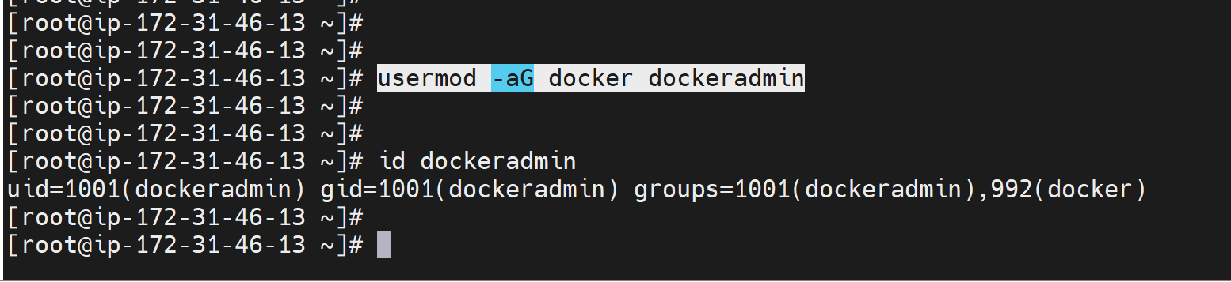

Now we can see dockeradmin added to the group docker.

By default password based authentication is not active so we will not be able to login with dockeradmin. To change it we have to edit **vi /etc/ssh/sshd_config**

Here PasswordAuthentication is set to No. we have to make changes to enable password authentication.

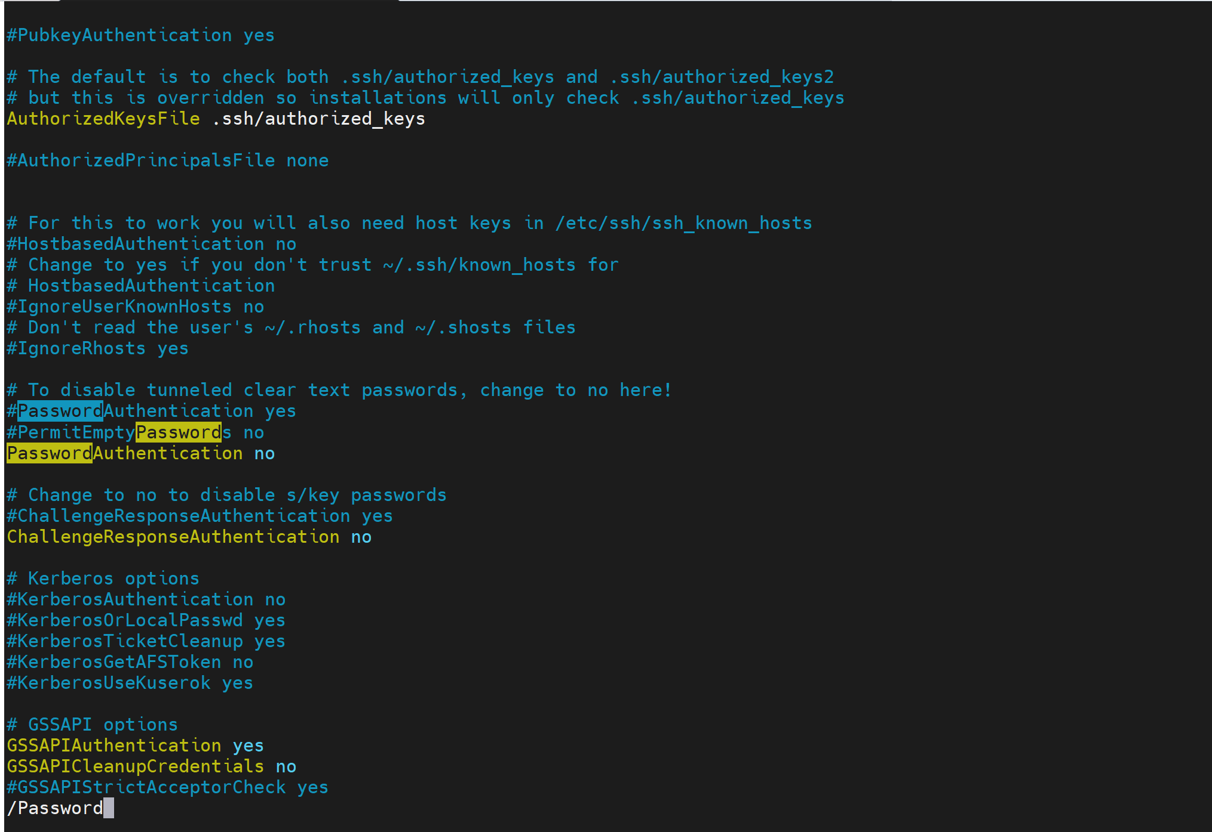

after making change🡪

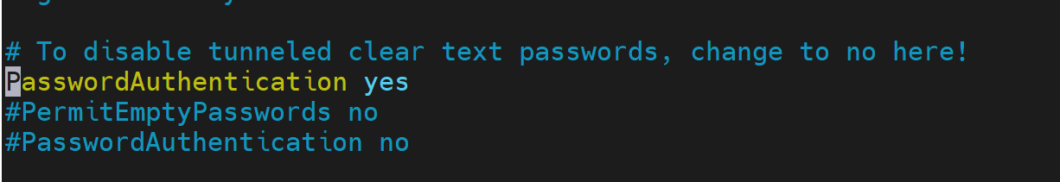

Command **service sshd reload** to pick the newly modified file.

**Add a Plugin in Jenkins “Publish Over SSH”**

Install the plugin **Publish Over ssh**

Go to manage Jenkins> Configure System we can see “Publish Over SSH” there.

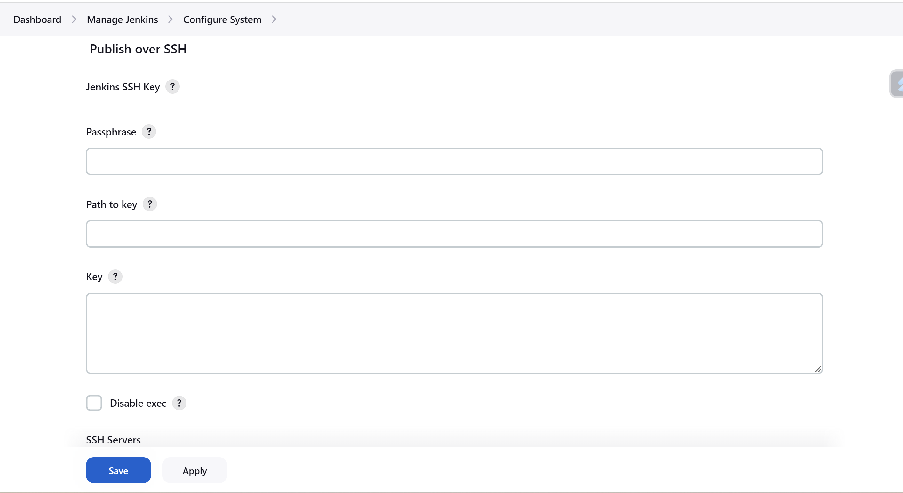

Can give private IP on host as well and fill the details:

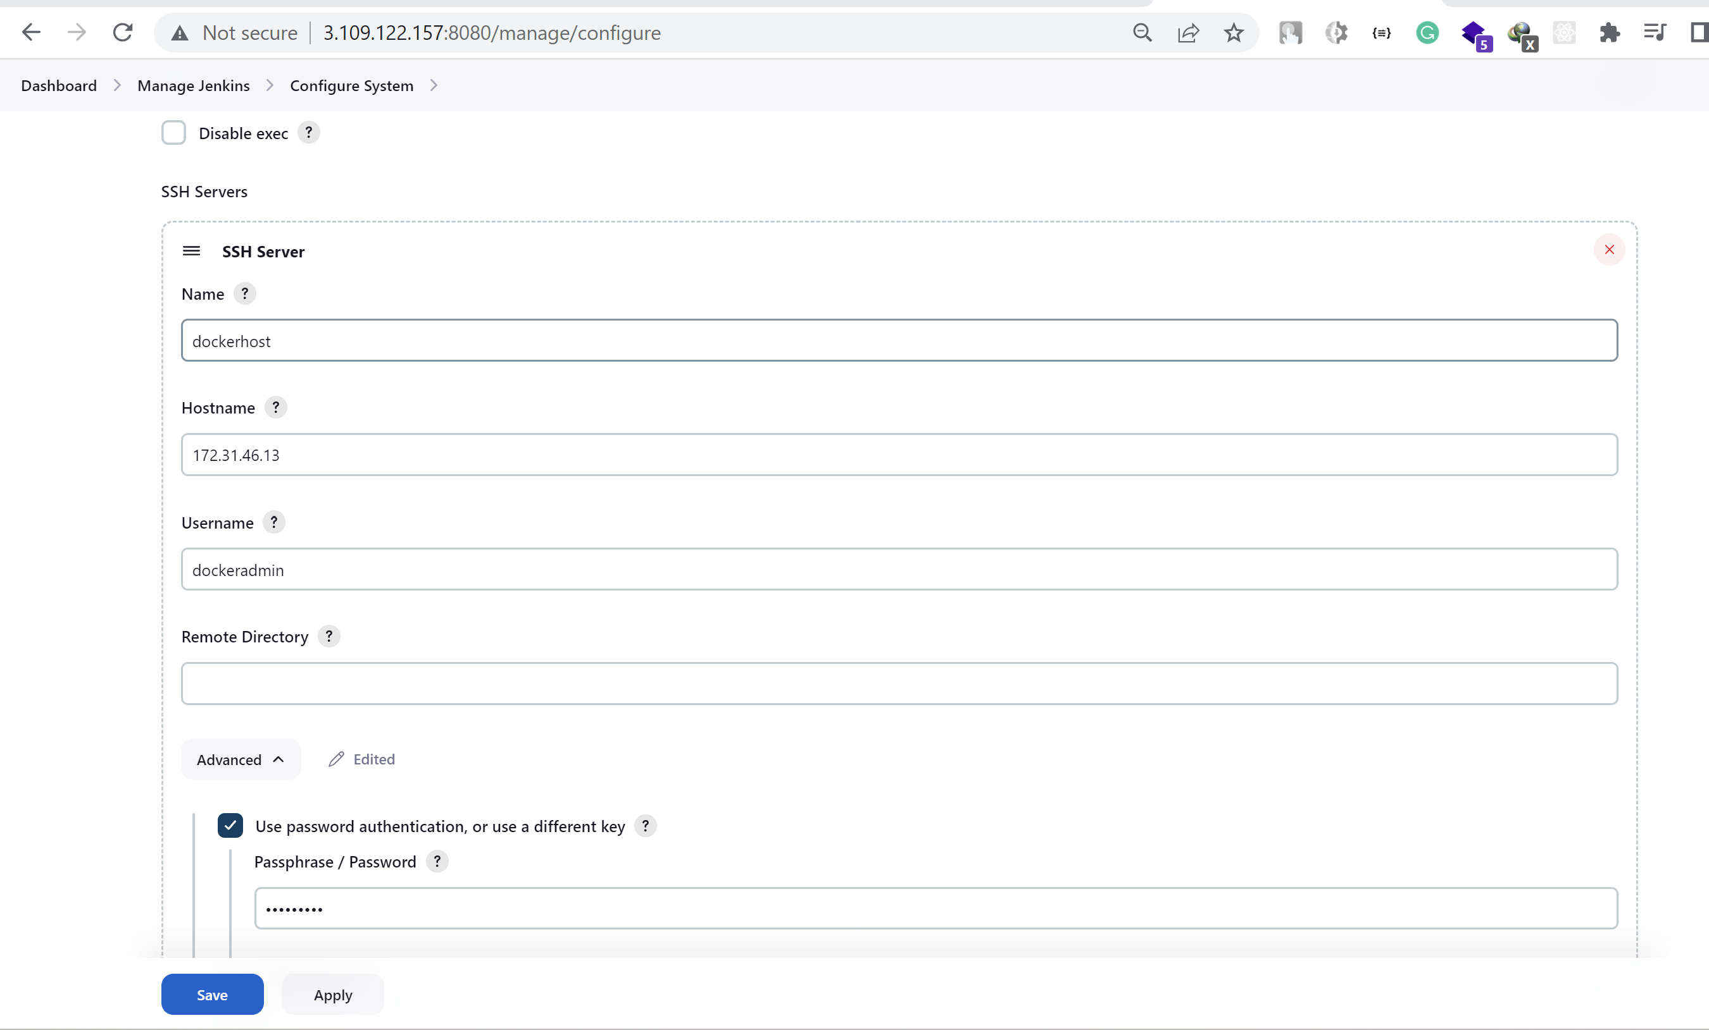

We can use keys as well but here we are using password based authentication.

Test Configuration giving success.

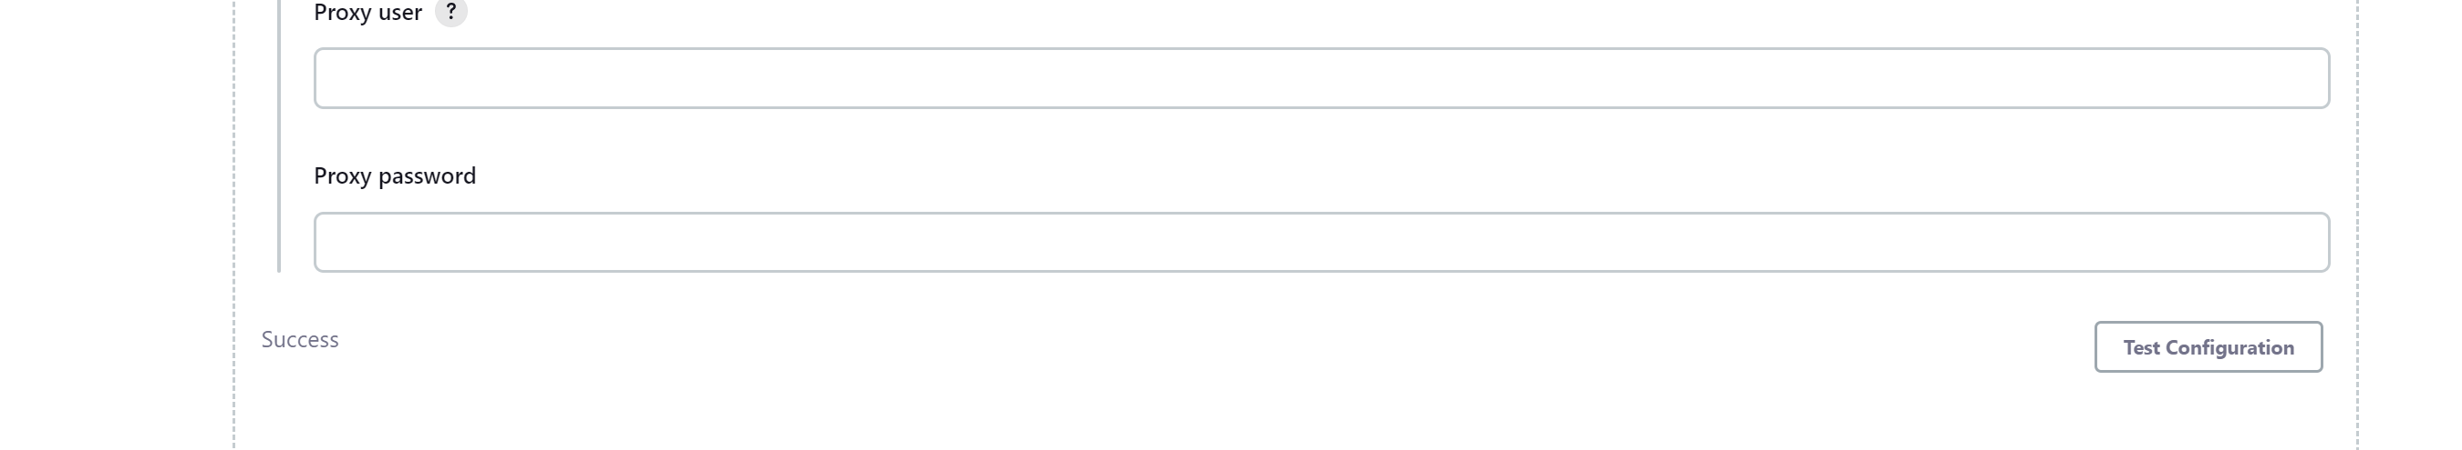

**Jenkins Job to build and deploy artifacts in dockerhost**

Creating new job and copying configuration from existing job buildAndDeplyJob 🡪

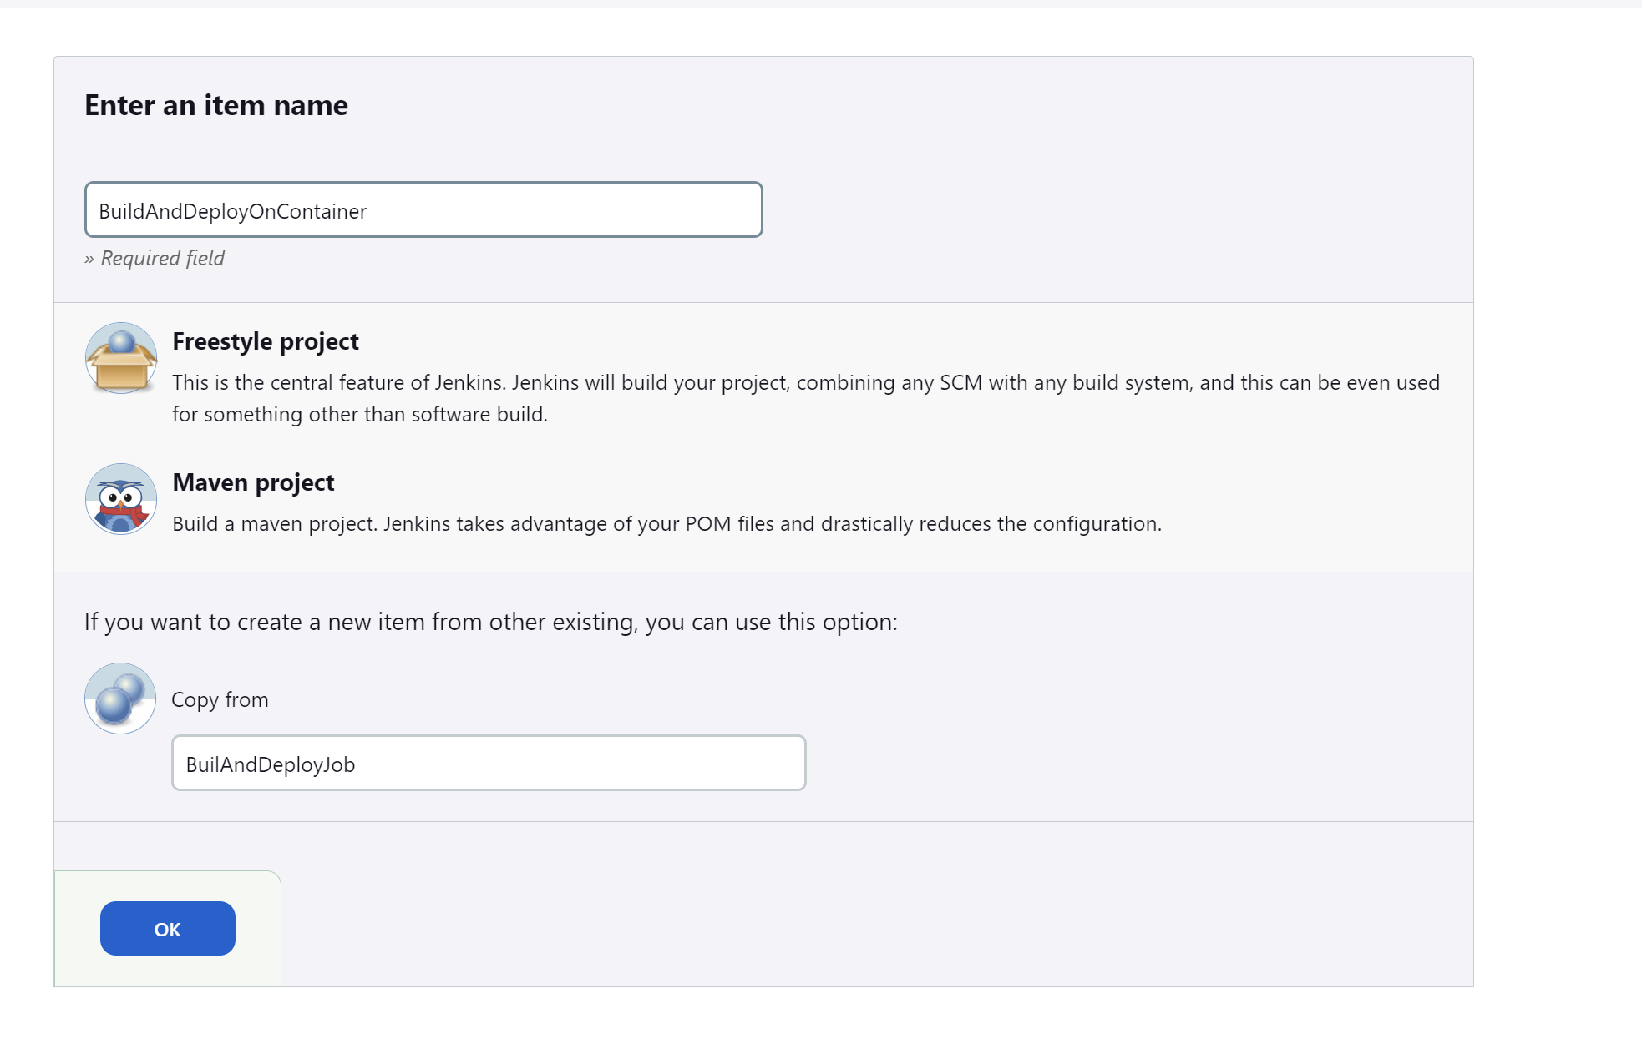

In post build steps add “Send build artifacts over ssh”

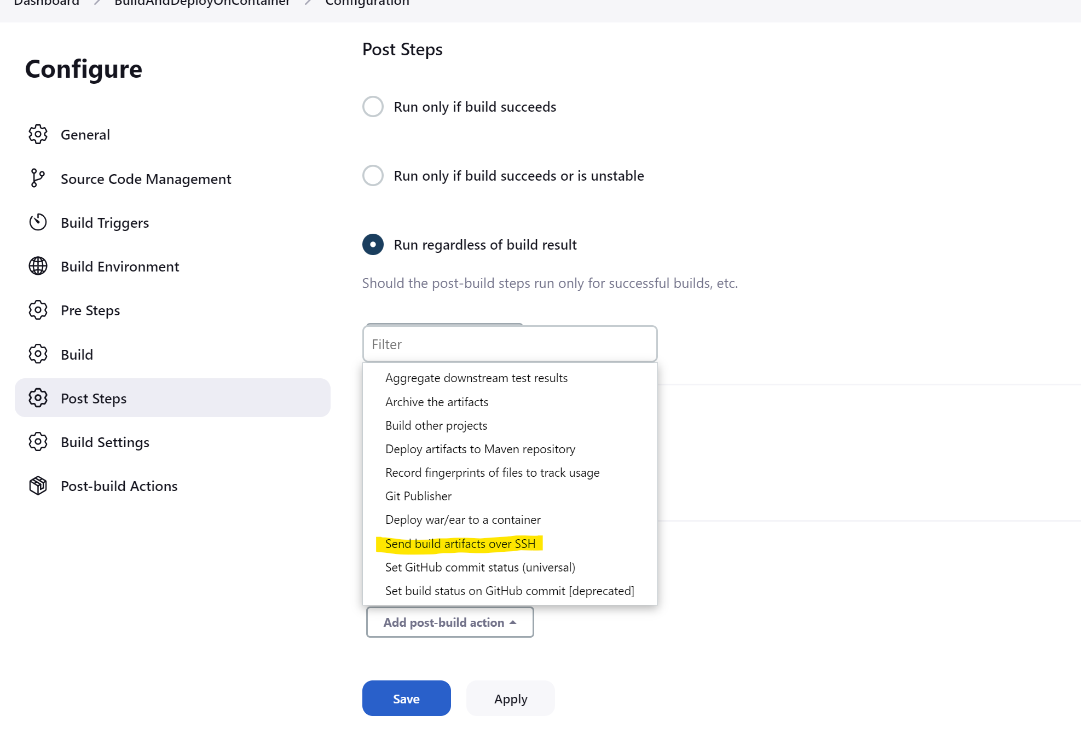

Add the SSh server name and the directory from and to the war files get copied.

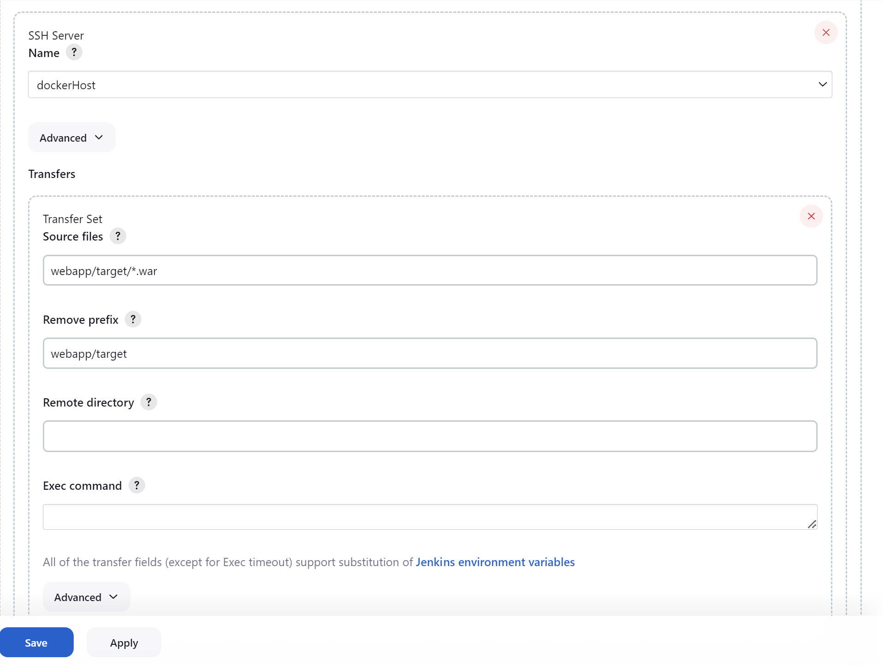

Before building our maven job we have 0 file inside the folder /home/dockeradmin

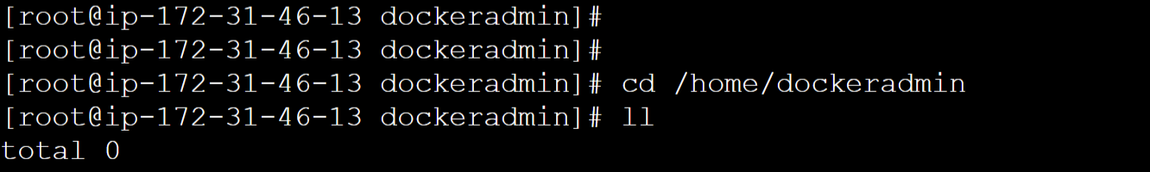

After building the job

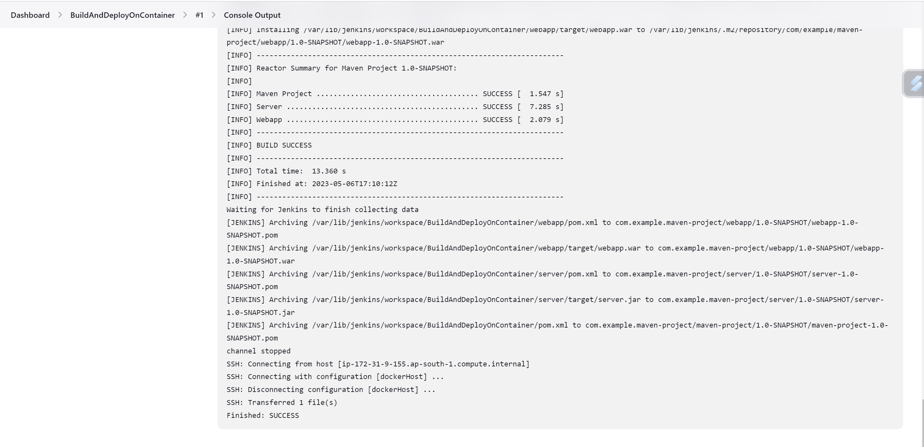

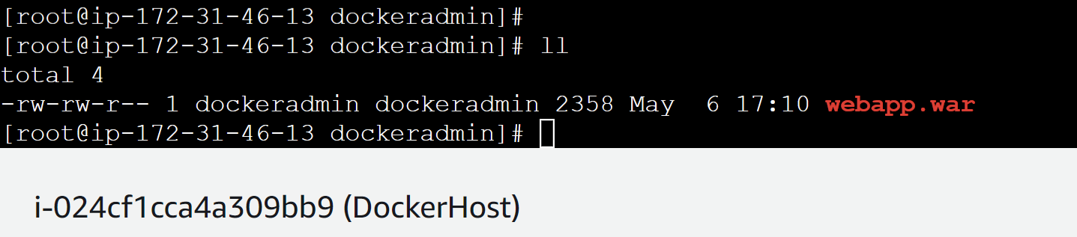

**Automating deployment process**

First creating a separate directory where we will have our artifacts(war file), dockerfile to create the image.

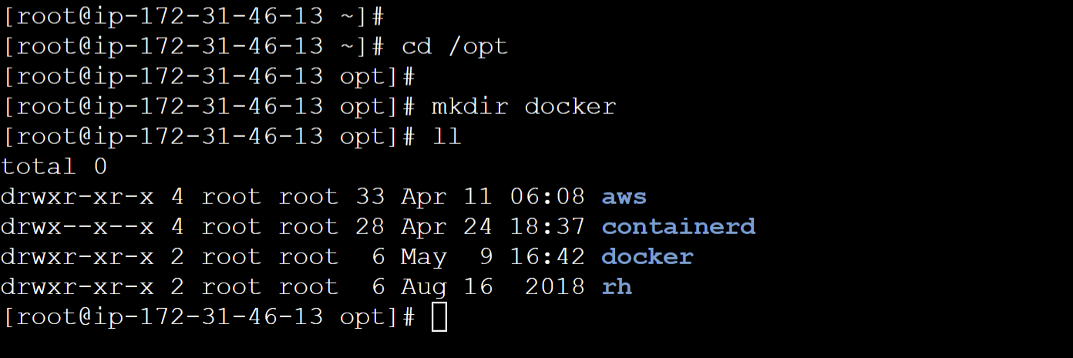

Giving the ownership of docker directory to dockeradmin.

Cmd🡪 **chown -R dockeradmin:dockeradmin docker**

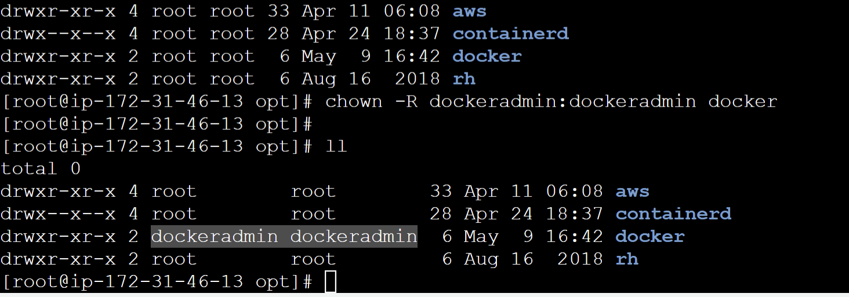

Moving our existing created Dockerfile to /opt/docker directory.

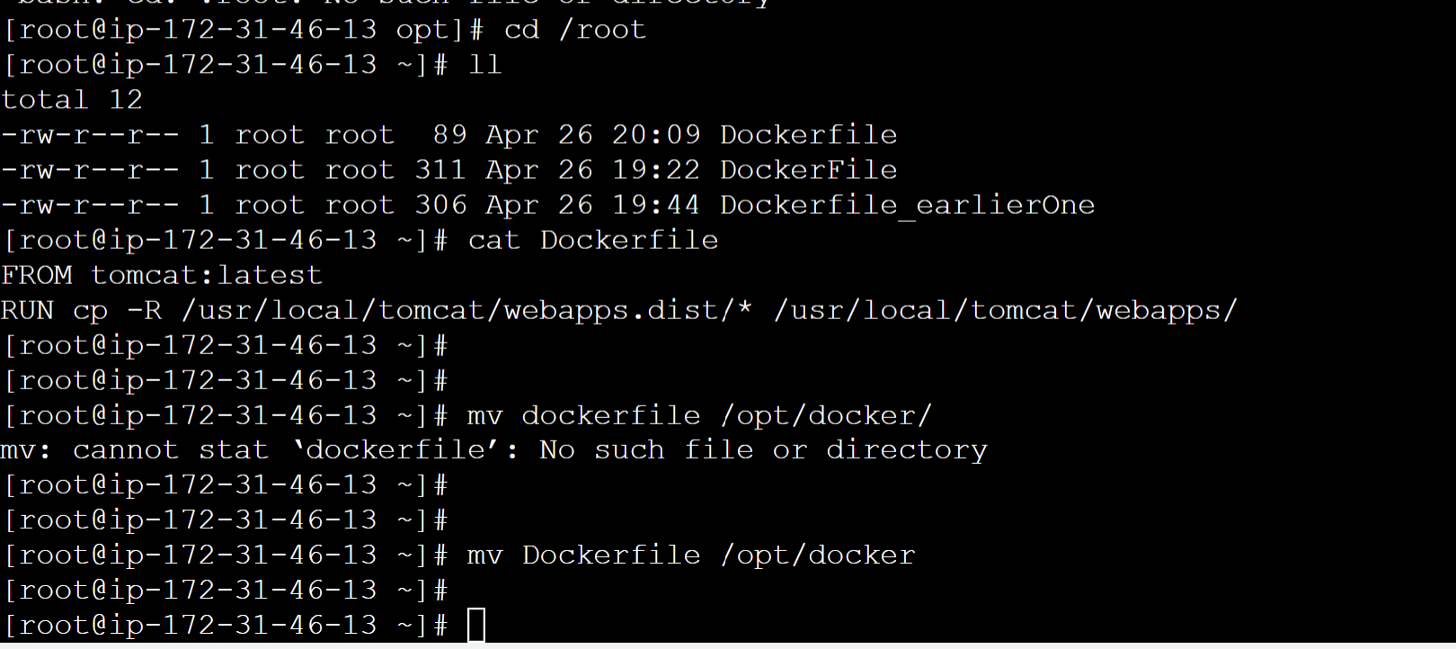

Giving the ownership of Dockerfile to dockeradmin user.

Cmd🡪 **chown -R dockeradmin:dockeradmin Dockerfile**

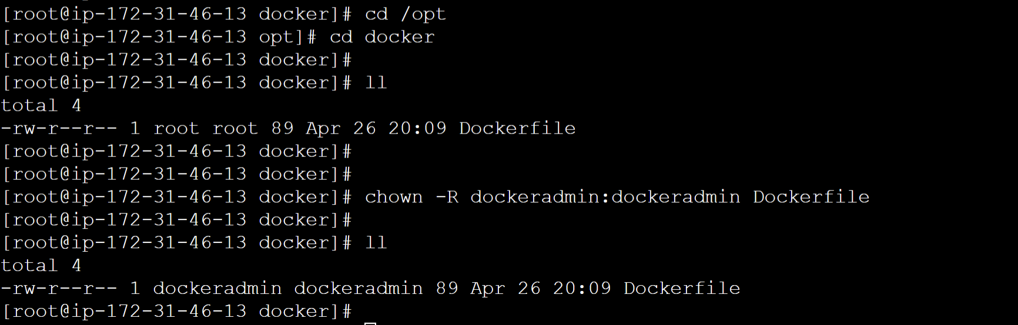

Now editing the Jenkins job having remote directory section.

Blank remote directory section means it will copy to root directory, now changing it to new path //opt//docker/ (if not used double slash then it will copy it to dockeradmin home directory) where we will be having all the things copied.

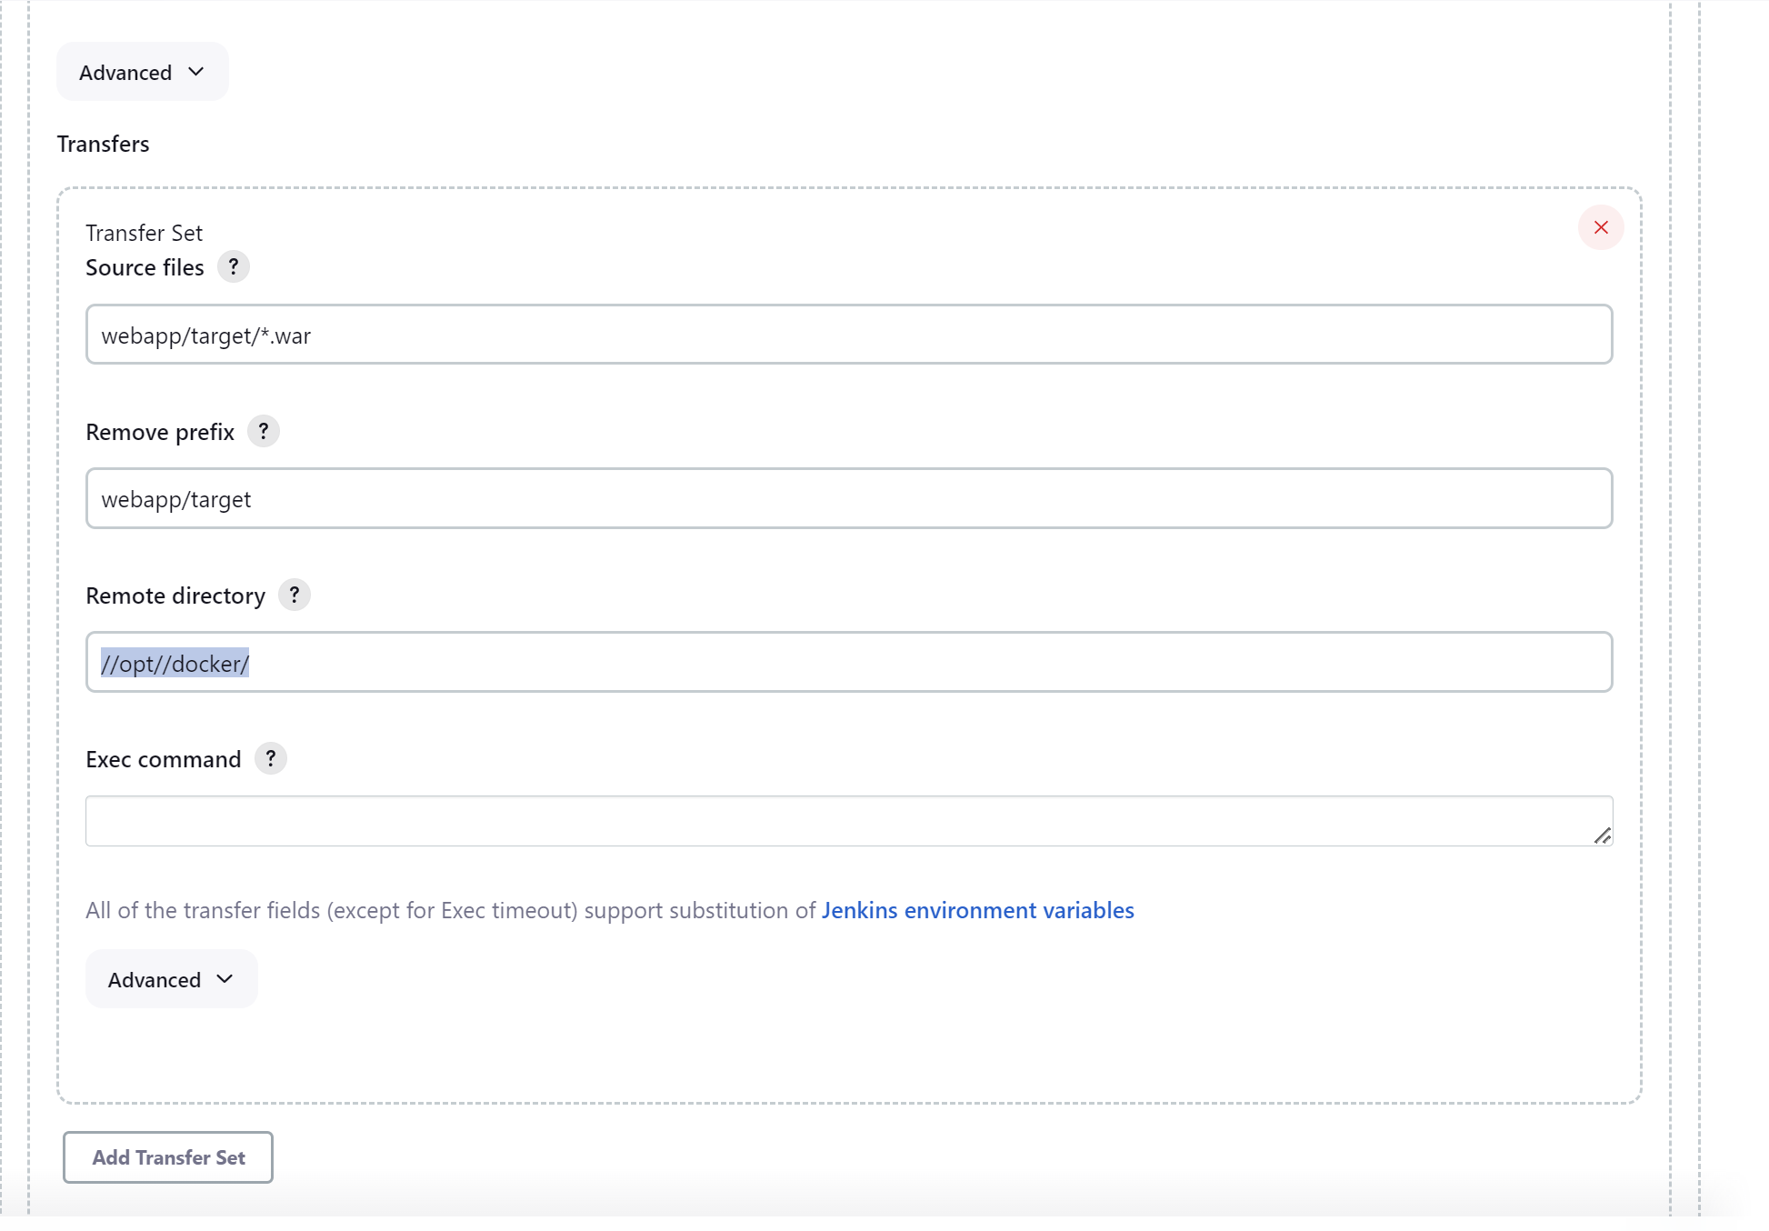

**Note:** IP to dockerhost should be updated because when instance is restarted the IP gets changed.

After running the job we can see artifact copying to the directory /opt/docker/

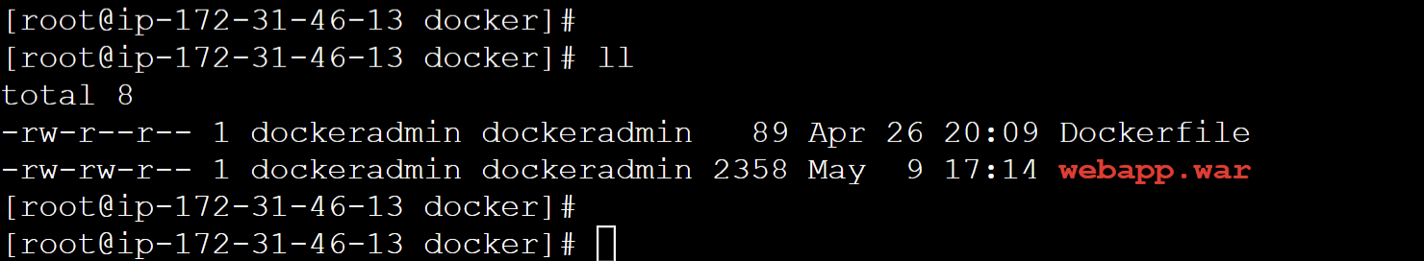

Editing Dockerfile to copy the artifacts in tomcat directory

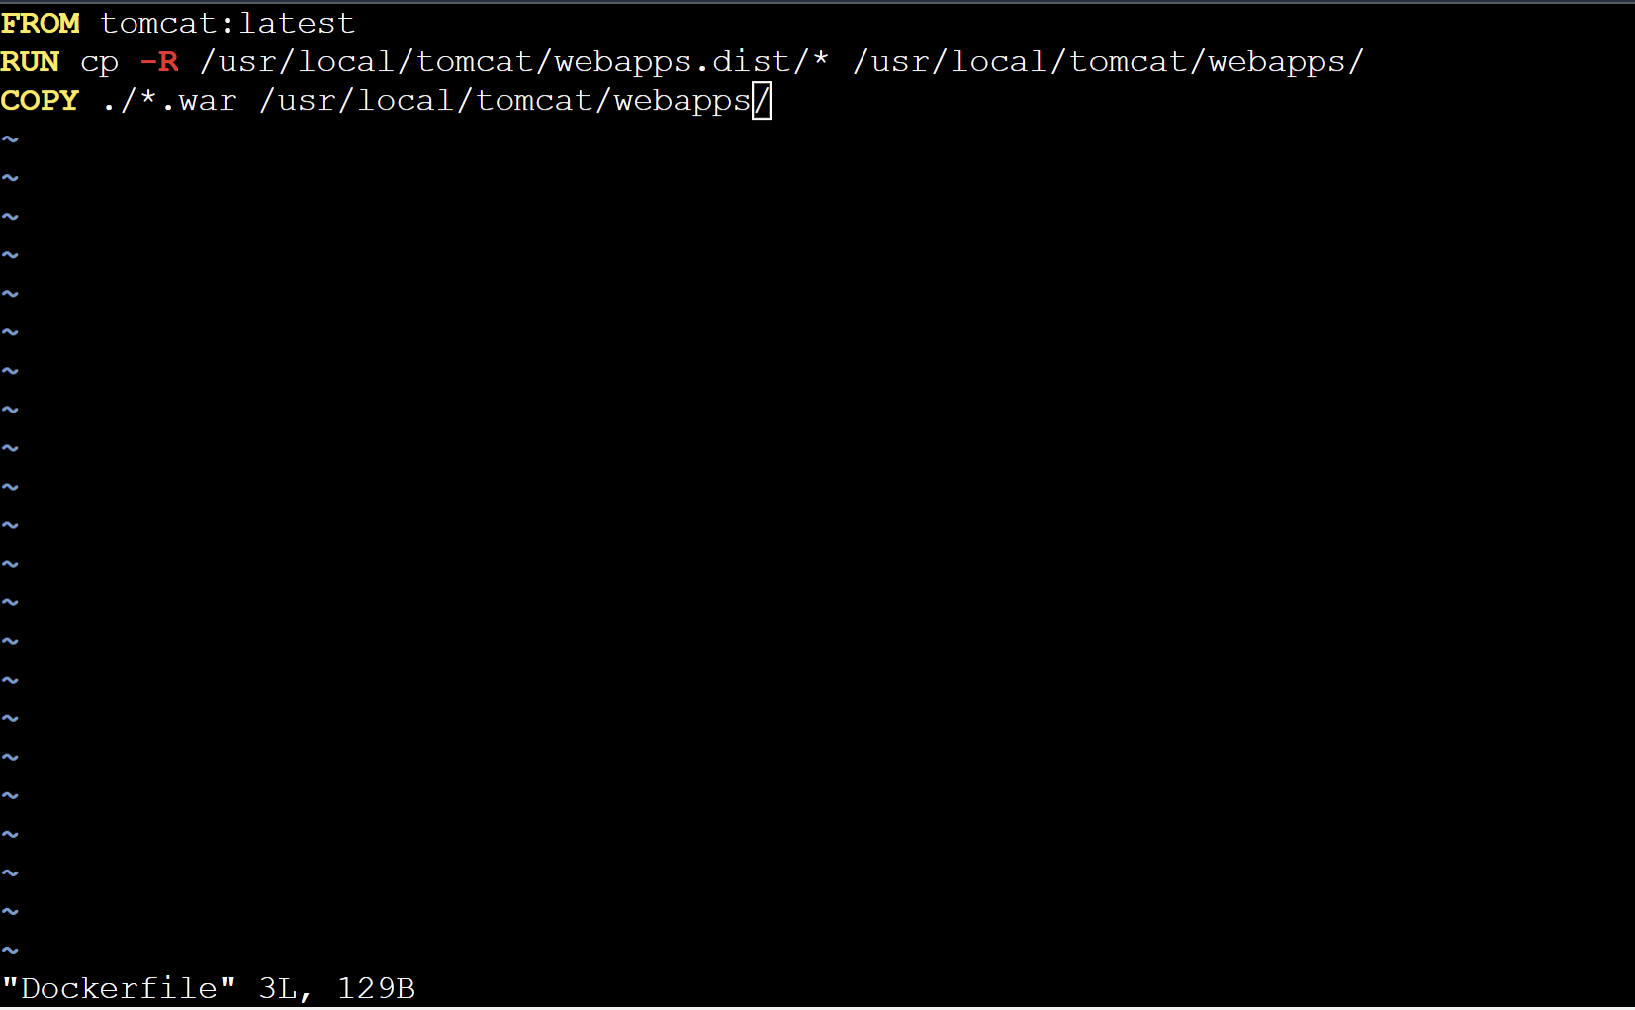

Now creating an image via the Dockerfile as **docker build -t tomcat:v1 .**

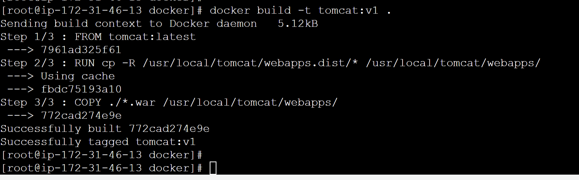

Running docker image

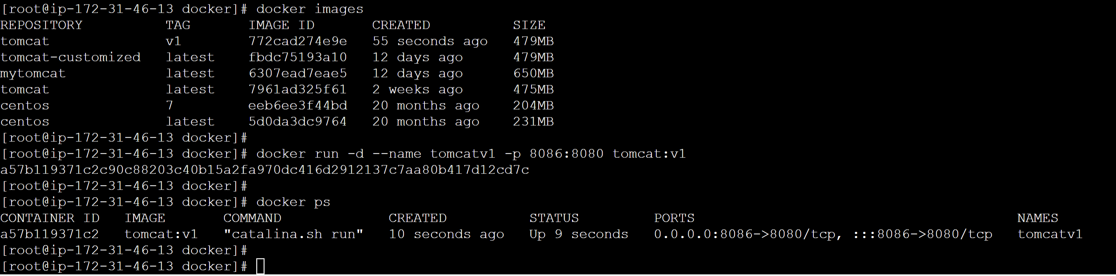

Accessing the application now on port 8086 as IP:8086

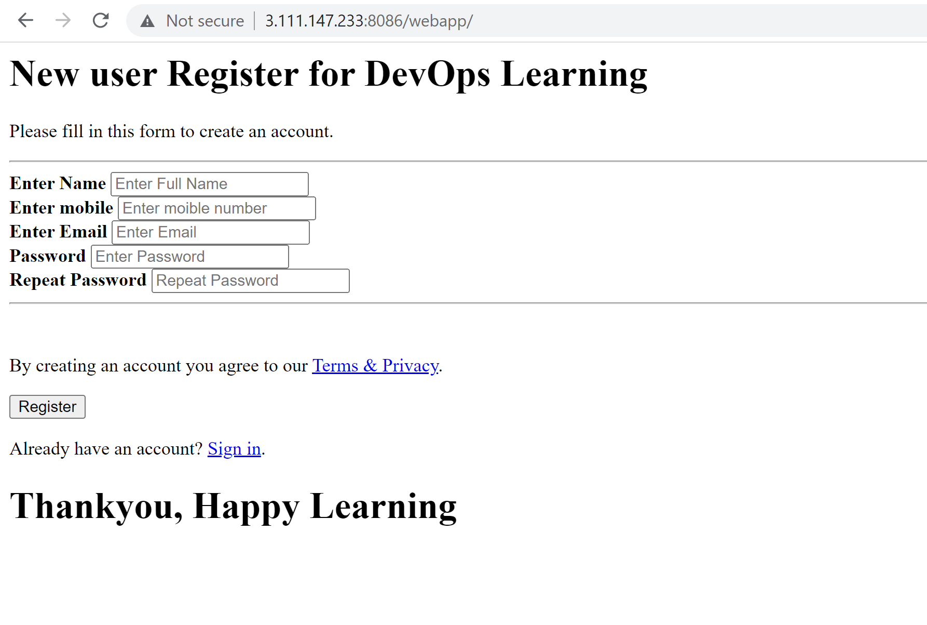

**Automate Build and Deployment on Docker Container**

As we were building and creating containers manually. We need automate these things as well.

For this purpose, we are having **exec command** section in “publish over ssh” in Jenkins there we can give commands.

For building docker build and docker run we have the commands in place as:

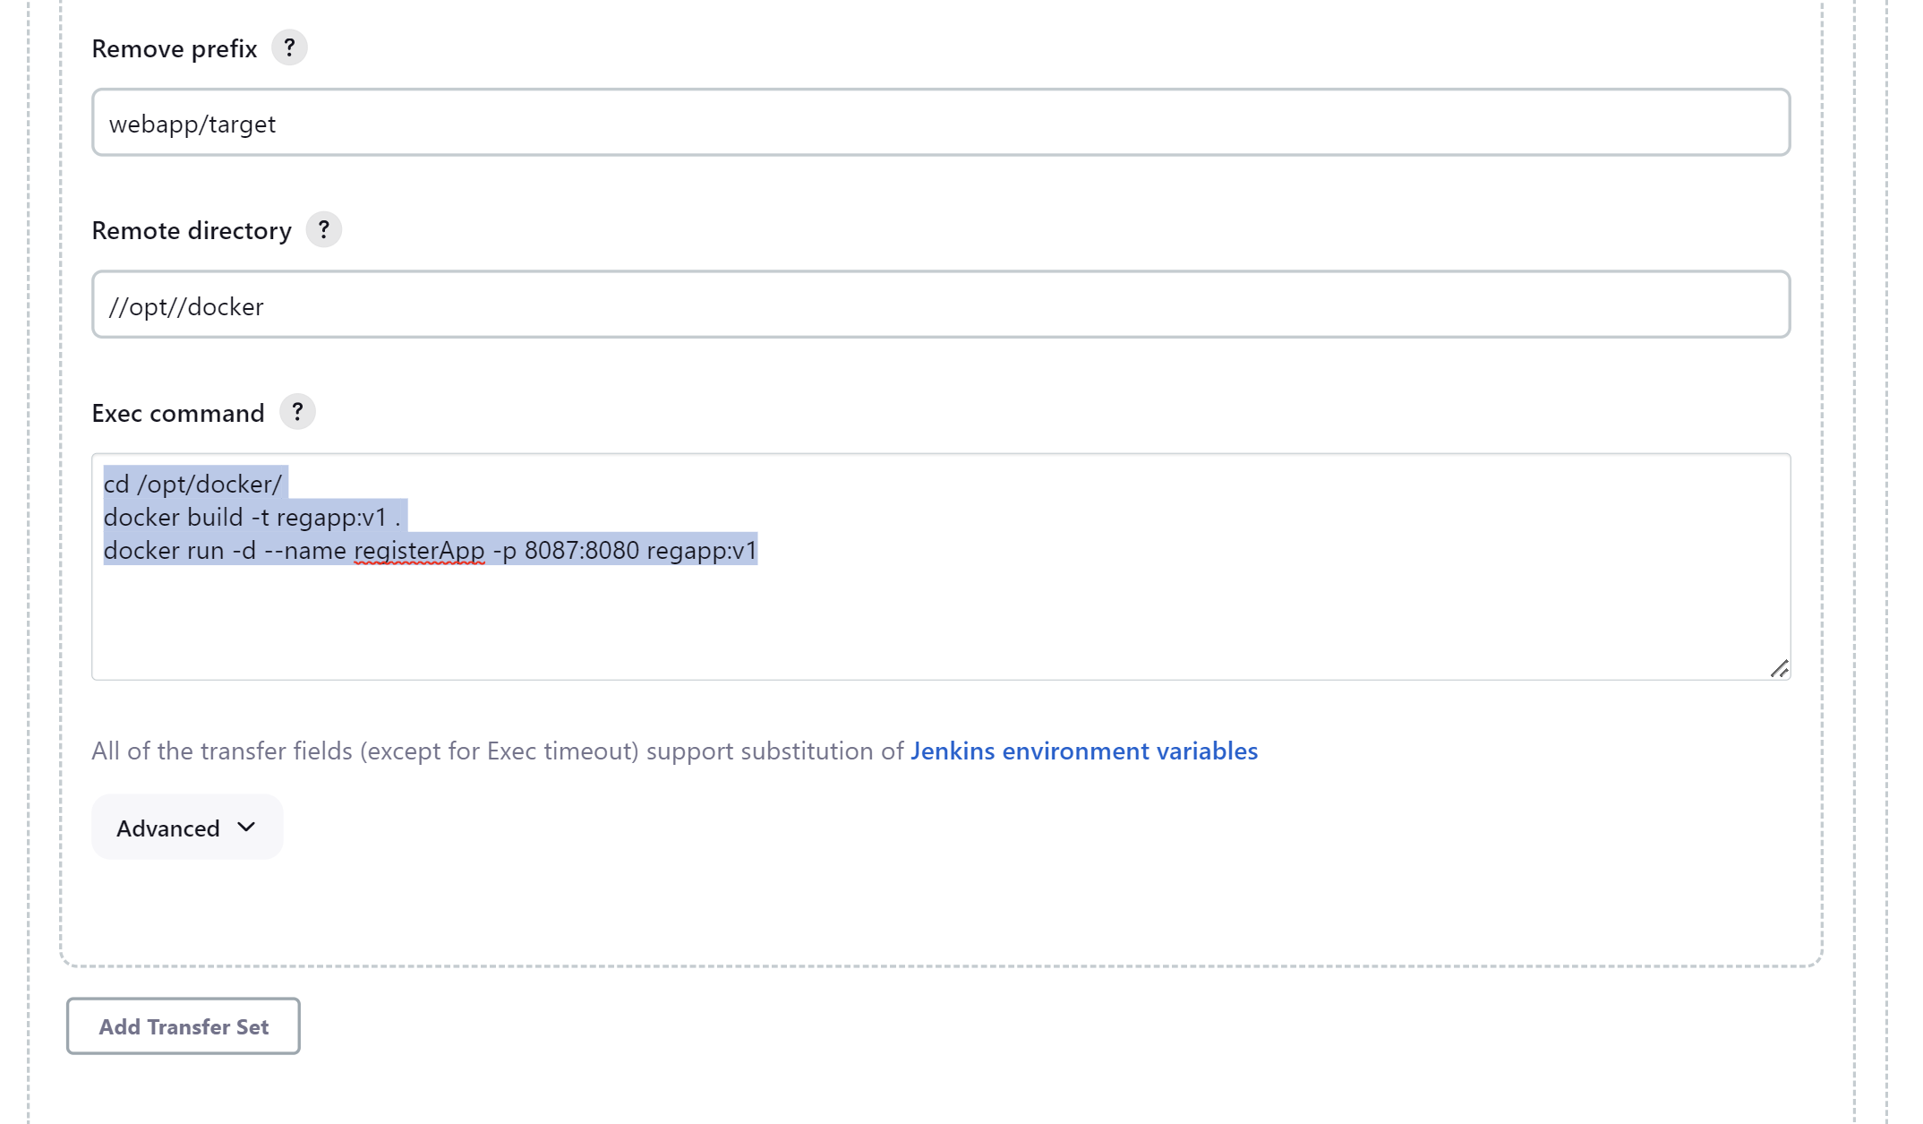

Now the whole process is automated.

**docker container prune 🡪** To delete all stopped containers

**docker image prune -a 🡪** To delete all images.

Application start running on port 8087. The exec command will not work if the application is already running, in that case we have to stop existing container.

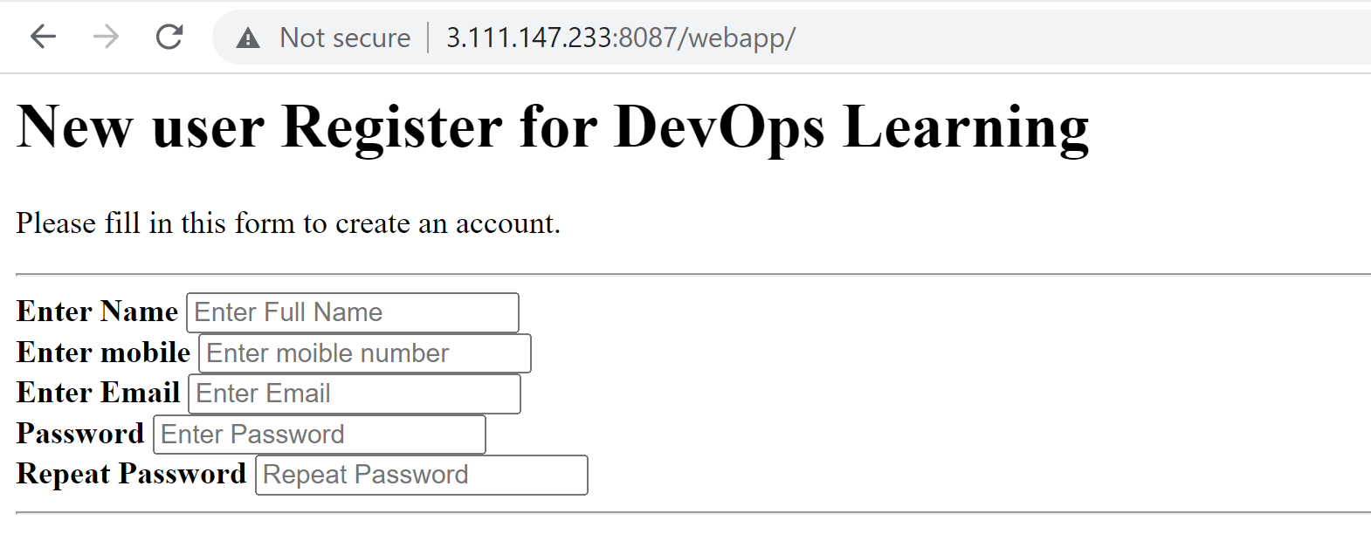

If we have the container already running then we can have two more commands in Jenkins exec statement as 🡪

**docker stop registerApp**

**docker rm registerApp**

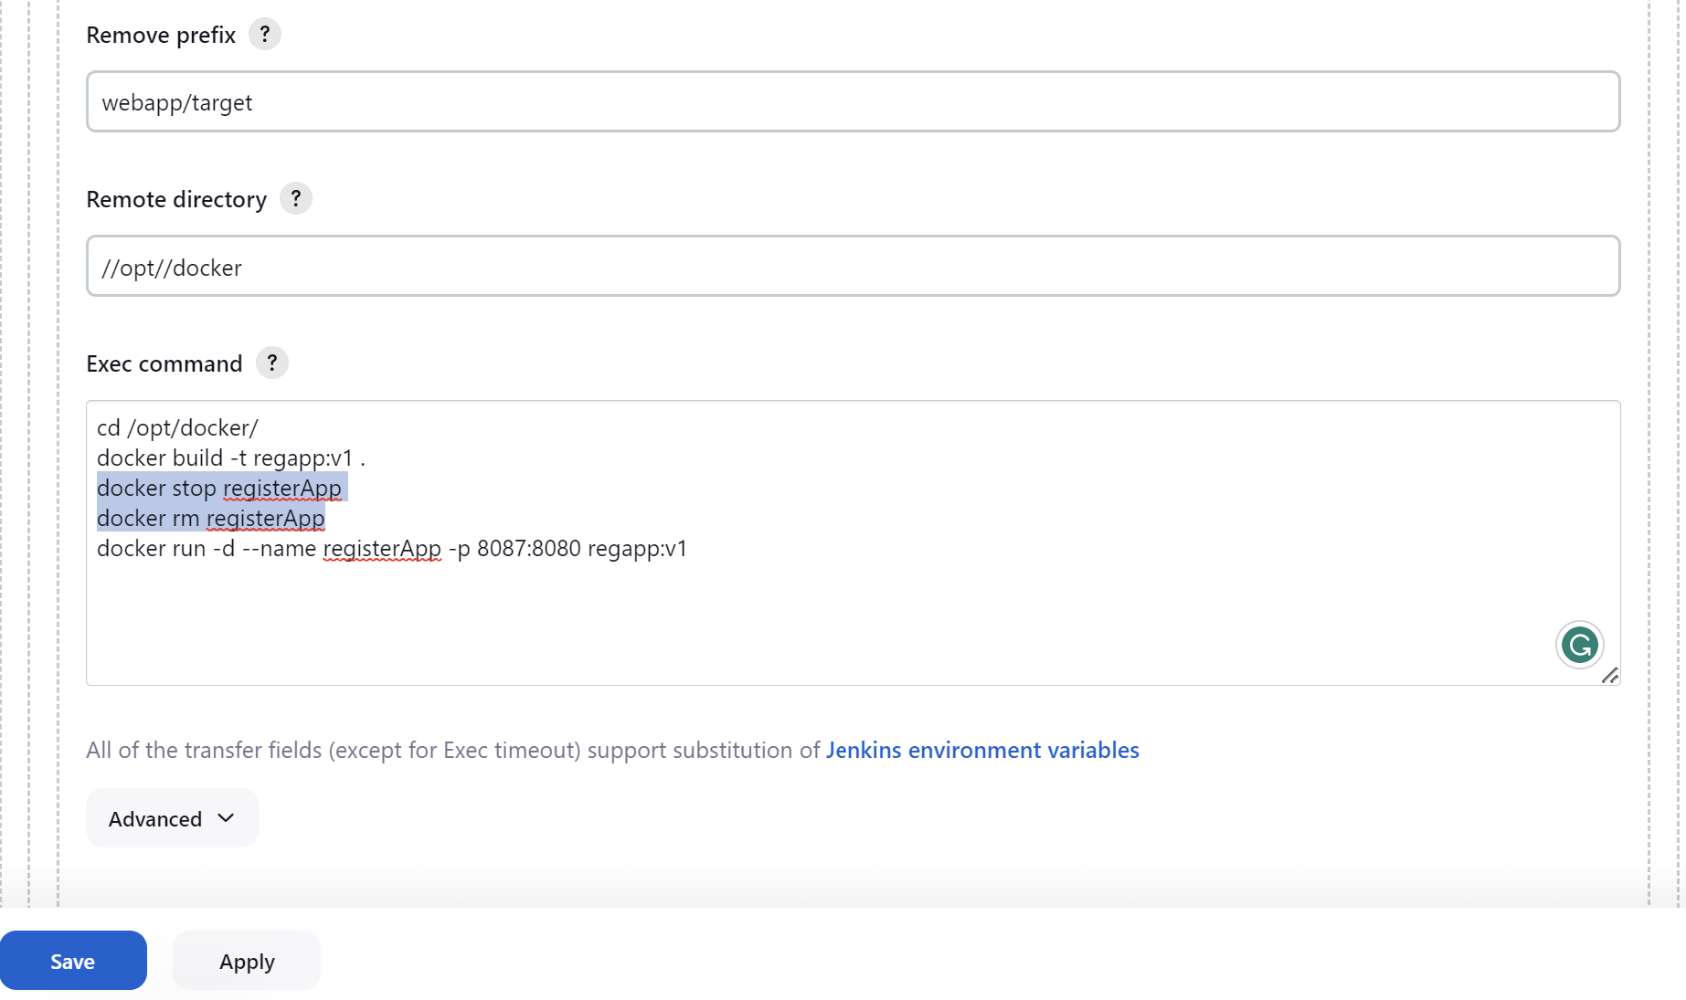

**Ansible**